Date of issue: TBC
Reference: 18-754-OPTIPLEX-DDL-EuroBLECH-FINAL
Media release

Mazak premieres new OPTIPLEX DDL at EuroBLECH 2018
A new version of Mazak’s state-of-the-art OPTIPLEX DDL range is set to make its European premiere at EuroBLECH 2018.
The new version of the OPTIPLEX 3015 DDL, which stands for direct diode laser, promises enhanced productivity and performance due to its market-leading 6kW resonator that has been specially tuned for medium and thick materials with enforced heat resistant plates.
The new machine is ideal for the high-speed cutting of stainless steel and aluminium, and is able to cut mild and thick steel 30-50 per cent faster than the 4kW version. In operation, the new DDL is capable of rapid traverse rates of 120m/min in the X- and Y-axes, and 60m/min in the Z-axis.
The machine also boasts an increased maximum thickness to cut, specifically 25mm with mild and stainless steel and 25mm with aluminium.
With ultra-high speeds however, there has been no compromise on the quality of the cut with thick and mild steel. The machine produces finished workpieces with reduced depth of cut lines compared to the 4kW version and a smooth cut surface. To aid cut accuracy, the new DDL is capable of positioning accuracy of ±0.05mm/500mm in the X- and Y-axes and ±0.01mm in the Z-axis.
The OPTIPLEX DDL Multi-Control Torch is exclusive to the DDL, equipped with an optical filter with reflection coatings to protect the optical sensors against scattered lights, all the time ensuring that contamination of the protective window from spatter is avoided.
Stable cutting from thin to thick material is guaranteed with the use of Beam Diameter Control. The new 6kW DDL is also equipped with a series of Intelligent Monitoring Functions that optimise cutting and also a suite of intelligent functions, including Intelligent Set-up, that can result in a 15 per cent increase in productivity.
The machine is controlled by MAZATROL PreviewG, the specially developed laser programming CNC of the SMOOTH Technology range. PreviewG has a large 19” touch screen with operation similar to a smartphone or tablet enabling easy programming for the operator.
Ends

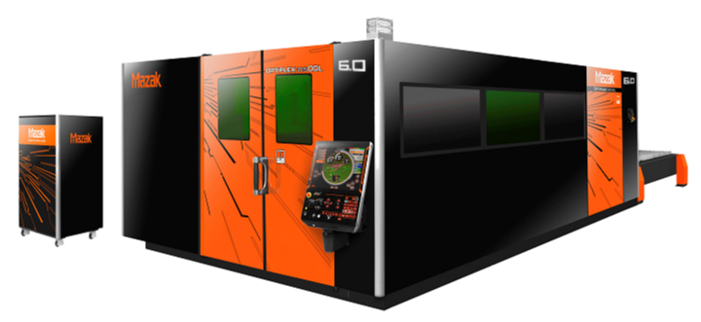

Photo caption 1: The new version of the OPTIPLEX 3015 DDL promises enhanced productivity and performance due to its market-leading 6kW fibre resonator that has been specially tuned for medium and thick materials with enforced heat resistant plates.

Issued on behalf of: Media Contact:
Yamazaki Mazak U.K. Limited Tom Leatherbarrow
Badgeworth Drive Willoughby Public Relations,
Worcester 43 Calthorpe Road
Worcestershire Edgbaston
WR4 9NF Birmingham
Tel: 01905 755755 Tel: 0121 456 3004
Fax: 01905 755001 Fax: 0121 456 9300
e-mail: sales@mazak.co.uk e-mail: tom@wpragency.co.uk
Website: www.mazakeu.co.uk Website: www.wpragency.co.uk

Contact: Maja Foster
European Marketing Manager

