Press Release
EMO Hannover 2019: KLINGELNBERG brings new impetus to the robot and aerospace industry
Hückeswagen, Germany, September 2019
Klingelnberg, the mechanical engineering company specializing in gear and transmission technology, is celebrating several premieres at EMO Hannover 2019 in September: with the VIPER 500 MFM, the company is entering the cycloid gearing market, setting new standards in efficiency in the robotics industry. The OERLIKON G 35 Bevel Gear Grinding Machine also helps achieve this. With it, the manufacture of aviation gearing really takes off. Other trade fair highlights include the Speed Viper² 80, the P 26 precision measuring center with integrated optical measurement and the P 16 for complete measurement of rolling bearings including roughness measurement.
It is where the Who's Who of the international machine tool industry will meet again: at EMO Hannover 2019 from 16 to 21 September. According to the organizers, even more exhibitors than attended two years ago will be presenting themselves at the world's leading trade fair for metalworking this year. Among them is the mechanical engineering company Klingelnberg, which, true to the trade fair motto "Smart technologies driving tomorrow's production!" will use this platform to inspire with innovative pioneering achievements. In particular, the gearing specialist surprises with the development of a new market, cycloid gearing. With the VIPER 500 MFM, the company is freshly entering this sector and thus opening up new perspectives for the robotics industry. Klingelnberg has also launched a new product for the aviation sector in the form of the G 35, which will undoubtedly provide new impetus in terms of efficiency. The new

machine design for the 5-cut method with its further developed dual-spindle concept raises the production processes in this area to a new level.
While this year's EMO underlines the company's claim to position itself as a platform for networking in production with the new IoT exhibition area, Klingelnberg already has various solutions in the trunk that can be used to easily and effectively implement Industry 4.0 processes in production. The Speed Viper² 80 dual-spindle machine not only offers significantly lower auxiliary times than those known on the market – it is also optimally designed for the production environment of Industry 4.0. The cylindrical gear machines from Klingelnberg can be networked directly with precision measuring centers such as the P 26 exhibited at the trade fair. In general, the P series has been impressing with a broad spectrum of possible measurement tasks, including optical measurement since the end of 2018.
VIPER 500 MFM – Increased productivity and precision in the robot industry
With the VIPER 500 MFM Klingelnberg is entering the market with a pioneering technological achievement. The company is entering the field of cycloid gearing and thus also the world of robotics. Trade fair visitors will be able to see the machine live in action for the first time at EMO Hannover 2019. A real highlight, for, thanks to sophisticated technology, the VIPER 500 MFM often eliminates the need for the time-consuming and costly measuring and pairing of components.
To obtain cycloid gears with good running qualities and high load capacity, extreme precision is required when manufacturing the gearings and the base body. Because the high accuracies cannot be adhered to with standard machine tools available on the market and typical machining sequences, the components are measured and paired according to their tolerance situation. This means high additional costs and tremendous logistical effort in production and assembly. Klingelnberg is breaking new ground in cycloid gearing machining with the completely newly developed VIPER 500 MFM. For the first time, the company has developed a machine that makes it possible to comply with these tight tolerances. This allows for significant cost reductions. For this extraordinary solution, Klingelnberg combines the Done-in-One principle with the internally developed Adaptive Grinding System. And that's exactly what's behind it: the VIPER 500 MFM combines the two precision-determining stages of bore hole and gear grinding on a single machine according to the Done-in-One principle. In adaptive grinding, the root circle diameter of the cycloid is produced relative to a very precisely known reference diameter by a skillful sequence of grinding and measuring operations. For the first time, it is

now possible to reliably maintain the critical tolerances for cycloid gearing. This opens up new, highly interesting possibilities, especially in the robotics industry.
With the VIPER 500 MFM in combination with the precision measuring centers and the Closed Loop, Klingelnberg now has a complete system that makes the production of highly accurate cycloid gearings very easy: in the cycloid grinding cell, the processing machine and the measuring machine are connected by automation. Thanks to the use of GearEngine®, this cycloid grinding cell is “fit” for Industry 4.0 processes. Combined with Closed Loop, this gives rise to an autonomous, self-optimizing production system that makes it possible to utilize the machining and measuring capacity of the machines to optimal effect.
G 35 – Dual-spindle machine with vertical concept really takes off
Just as innovative and inspiring is another innovation from Klingelnberg: with the Oerlikon G 35 Bevel Gear Grinding Machine, the gearing specialist has implemented a new machine design for the 5-cut method. As a result, the manufacture of aviation gearing as regards efficiency is really taking off. To achieve this, the system provider has combined proven technology with new ideas. Background: bevel gears manufactured using the 5-cut method with a fixed setting are used in the aviation industry. This entails the consecutive machining of convex and concave pinion flanks, with different tools and different machine settings. Due to complex certification procedures for aerospace applications, changing to another gearing is not an option. However, the newly developed Oerlikon G 35 Bevel Gear Grinding Machine makes the production of aerospace gearings much more efficient thanks to its technology: with its two vertically arranged grinding spindles, it is specially tailored to these requirements. In contrast to older dual-spindle concepts with fixed grinding spindles, the G 35 is equipped with two grinding heads that are positionable independently of each other, thus enabling maximum flexibility. The high rigidity and thermal stability ensure optimum machining results and, thanks to the advanced vertical concept, grinding sludge deposits in the working chamber can be avoided. Its name, "Clean Cabin", is thereby justified. The machine’s operating concept is based on the forward-looking KOP-G software interface, which is operated intuitively via a high-resolution touch screen. Function keys on the control panel thus provide direct access to frequently used setup functions.

Speed Viper² 80 – Productivity increase for cylindrical gears in mass production
Klingelnberg also provides tailor-made solutions for the automotive industry. At the EMO, Klingelnberg will present the Speed Viper² 80 Gear Generating Grinding Machine for workpieces up to 80 mm. The dual-spindle concept of the Speed Viper² is especially designed to meet the productivity requirements of the automotive industry and its suppliers. While the Höfler Cylindrical Gear Grinding Machines in the single-spindle version stand for high flexibility and short set-up times, the dual-spindle machines are designed for large series and minimum cycle times. The dual-spindle machine has two workpiece spindles in the turret, which enable simultaneous loading and unloading of the toothed gear during the grinding process. Thanks to its extensive experience with large, directly driven workpiece tables, Klingelnberg has been able to develop an extremely innovative drive for the turret. With an outside diameter of 320 mm and a width of 200 mm, the grinding worms ensure a long tool life while minimizing auxiliary times for tool changes. An automatic tool clamping system with an integrated balancing unit also contributes to shortened tooling times. As a result, in the Speed Viper², we were able to significantly reduce the auxiliary times typical of the market and achieve high productivity gains.
Thanks to the innovative automation concept, Speed Viper² 80 not only offers significantly lower auxiliary times than those known on the market – it is also optimally designed for the production environment of Industry 4.0. For the system supplier’s unique developments now make it possible to network a cylindrical gear machine directly with a measuring device. For many years, this technology was reserved exclusively for bevel gear machines.
P 26 precision measuring center with optical measuring technology
With the P 26, at the EMO Klingelnberg will also be presenting just such a precision measuring center, which is designed for future-proof quality management of gearings in the context of Industry 4.0 processes. The fully automatic CNC-controlled P 26 precision measuring center is designed as a compact unit for the workpiece diameter range up to 260 mm. The machine and software concept is optimized for the measurement of complex drive components using a technology that replaces up to six conventional measuring devices: gear measurement, general coordinate measurement, form and position measurement, roughness measurement, contour measurement and optical measuring technology. Optical measurement in particular is a new, extremely powerful option for precision measuring centers and has been available since the

end of 2018. It includes the HISPEED OPTOSCAN optical sensor with a rapid change feed unit, the software for sampling and visualizing the measured point cloud. The P 26 is presented in the ergonomically optimized Klingelnberg design, with which Klingelnberg will make its mark both at the EMO and in its customers’ production halls.
P 16 precision measuring center with rolling bearing analysis – Done in one
In addition, all KLINGELNBERG Precision Measuring Centers have the capability to accurately analyze and measure rolling bearings and rolling bearing elements to an extremely high degree of precision. The P 16 combines the coordinate, form and roughness measurement, including the functionality of a contour graph in a fully automated measuring run. Based on the manufacturer's data and specifications, automatic measuring runs and clear, conclusive protocols are created automatically in compliance with current standards and regulations. The series variations and quality grades of the bearings are supported by the innovative Klingelnberg software. Additional measurement tasks based on specific requirements of the bearing manufacturer can also be implemented with ease. The specifications of these highly accurate precision measuring centers make them ideal for in-process inspection of rolling bearings and rolling bearing elements in the immediate production environment.
Klingelnberg GearEngine® – New applications open up a wide range of possibilities
In 2017, GearEngine® was already the focus of attention at the EMO trade fair – with a view to how it combines design and production data as an IT system, thereby laying the foundations for exciting questions concerning tool life, machine status, component tracking, documentation, etc. Meanwhile the development with seven-league boots has progressed: applications such as SmartTooling for bevel gear production and the Closed Loop Production System for the Speed Viper cylindrical gear grinding machine have also been upgraded to this IT system.
Visitors to the EMO can obtain information about Klingelnberg’s entire innovation offensive in hall 26, booth B110. The on-site team is looking forward to interesting “shop talk” and stimulating discussions.

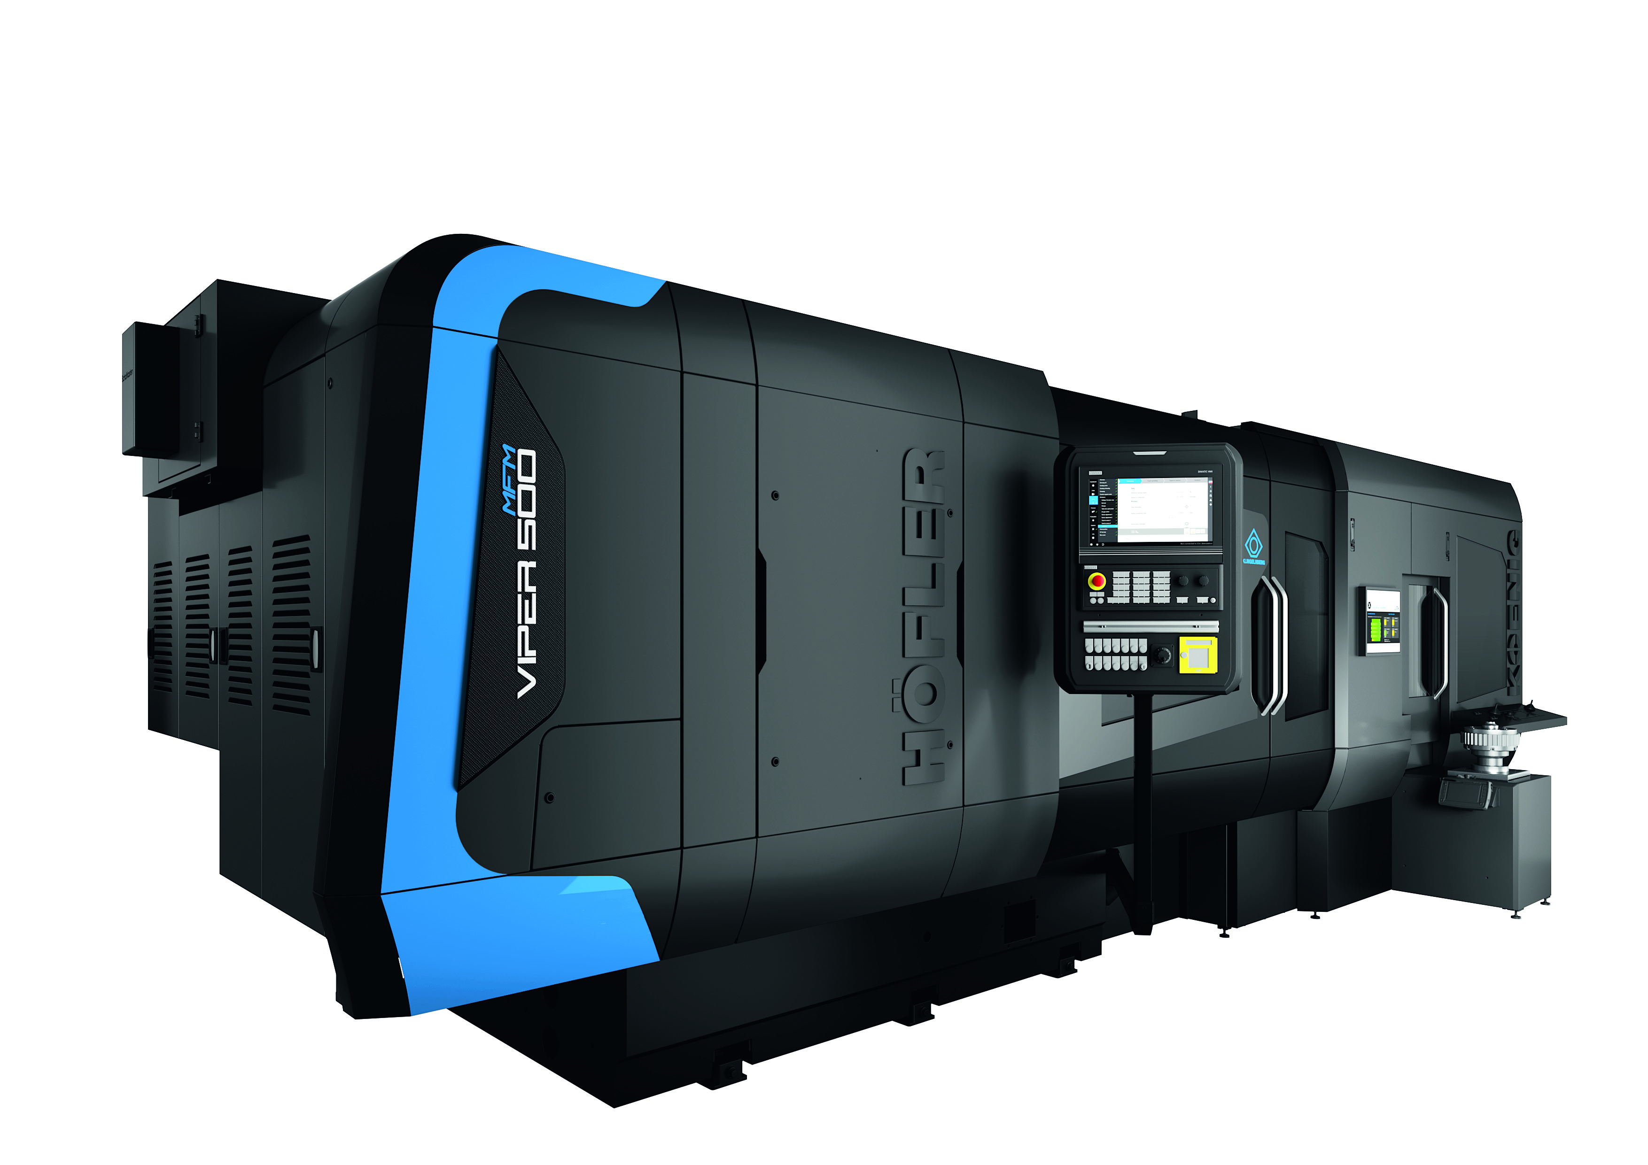
Image 1: VIPER 500 MFM for cycloid gears

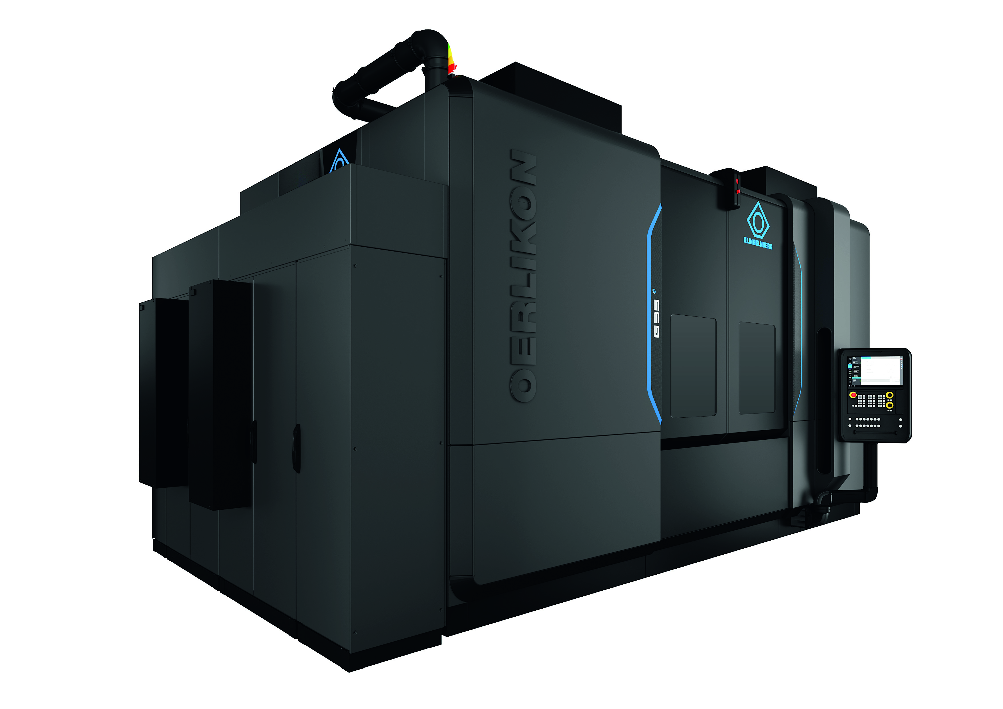
Image 2: OERLIKON Bevel Gear Grinding Machine G 35
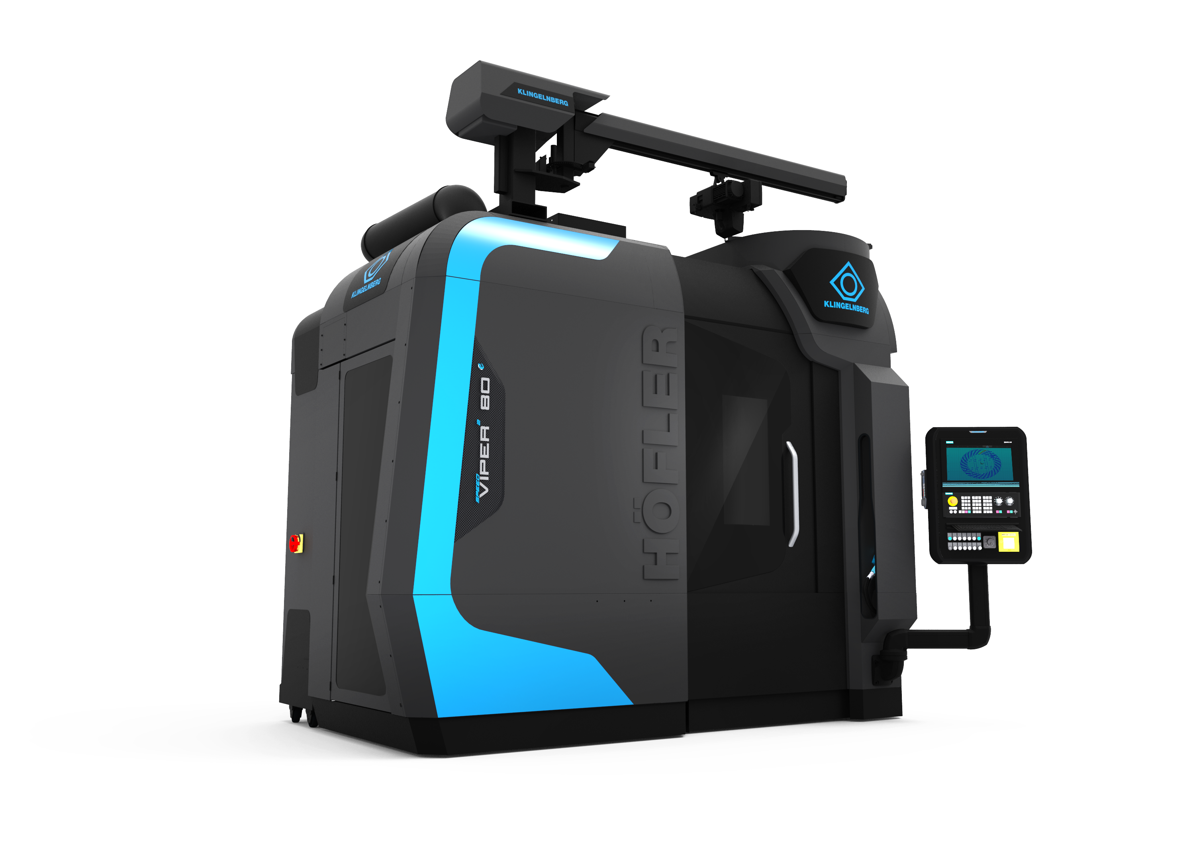
Image 3: HÖFLER Cylindrical Gear Generating Grinding Machine Speed Viper² 80

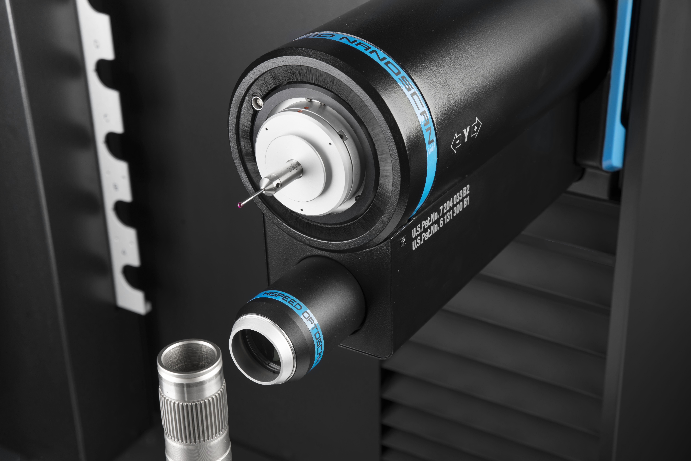
Image 4: Optical Metrology
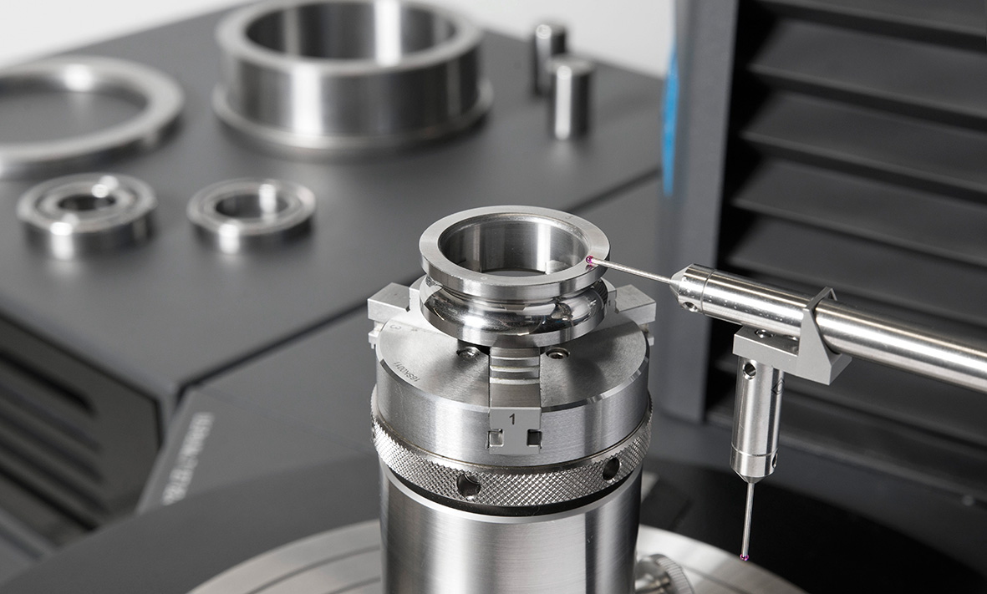
Image 5: Rolling Bearing Analysis
© KLINGELNBERG

*************************************************************************************************************************************************
Founded in 1863, Klingelnberg is one of the leading companies in the gear industry. Thanks to numerous innovations in the areas of calculation, production, and measuring technology, Klingelnberg considers itself a leader in this industry. With its acquisition of Höfler Maschinenbau GmbH’s core business in 2012, Klingelnberg has added machines for machining cylindrical gears to its range of products, reinforcing its position as a complete system provider.
Headquartered in Zurich, the machine manufacturing firm now develops and manufactures at its sites in Zurich, Hückeswagen, and Ettlingen, as well as Győr, Hungary. The company also maintains a presence with sales and service offices and numerous marketing agents all over the world. Klingelnberg solutions are used in the automotive, commercial vehicle, and aviation industries, as well as in shipbuilding, the wind power industry, and the general transmission manufacturing industry. Applications range from vehicle drives, aircraft turbine engines, and cement mill gear units to drive systems for ships and oil rigs.
With over 200 patent grants, the company continuously demonstrates its capacity for innovation. Above and beyond this, its 14001 certification and participation in the VDMA’s Blue Competence initiative give credence to the company's sustainable, environmentally sound business practices.

