Press release by MPDV

Role change in the system communication

The new Factory Collaboration Hub is now available for communication
between third-party systems and MPDV systems.

Mosbach, November 21st, 2019 – We have in production a multitude of systems. Those who previously wanted to exchange information between the MES HYDRA and its third-party systems used the MPDV service interface.

The Service Interface works according to the Request & Response principle, which means that the third-party system puts down a question and the MPDV system answers. That enables users to request the status of a machine or to inform themselves on the order progress. With the new Factory Collaboration Hub from MPDV, the third-party system now receives this information automatically.

All systems on one level of knowledge
The Factory Collaboration Hub works according to the Publish & Subscribe principle. This means that the third-party system subscribes to the message channel of the MPDV system and receives all information from this point in time without having to send a request.

The advantage: thanks to the continuous exchange of information, the third-party system is always kept at the same level of knowledge as HYDRA and can react immediately if necessary. The Factory Collaboration Hub is particularly suitable for automation control in production, for connecting information displays that show the status of production in real time, or for operating several MES systems.

Two ways, one destination
Both solutions fulfill their task to supply third-party systems with information. Depending on the application, one or the other communication strategy may be more suitable. Always focused on how up-to-date the information required by the third-party system needs to be. The key factor here is whether information from the third-party system should also be fed into the MPDV system. If so, then the service interface is more suitable, as only one system supports communication in both directions. Both options can also be combined.

MPDV offers both the Service Interface and the Factory Collaboration Hub for the MES HYDRA and the Manufacturing Integration Platform (MIP). Both functions underline the openness of MPDV's IT solutions.

(ca. 2.400 characters)

Pictures
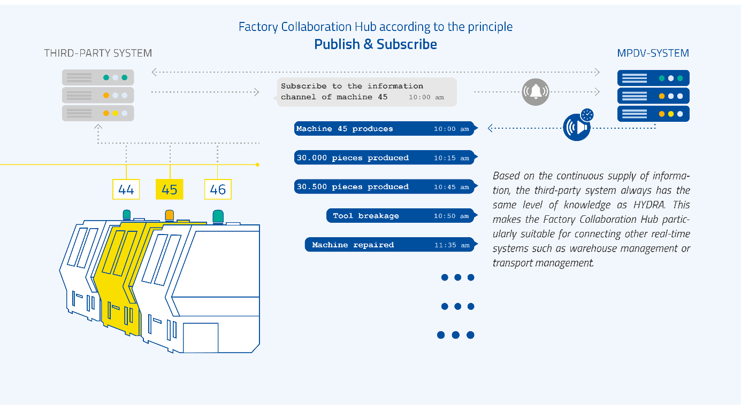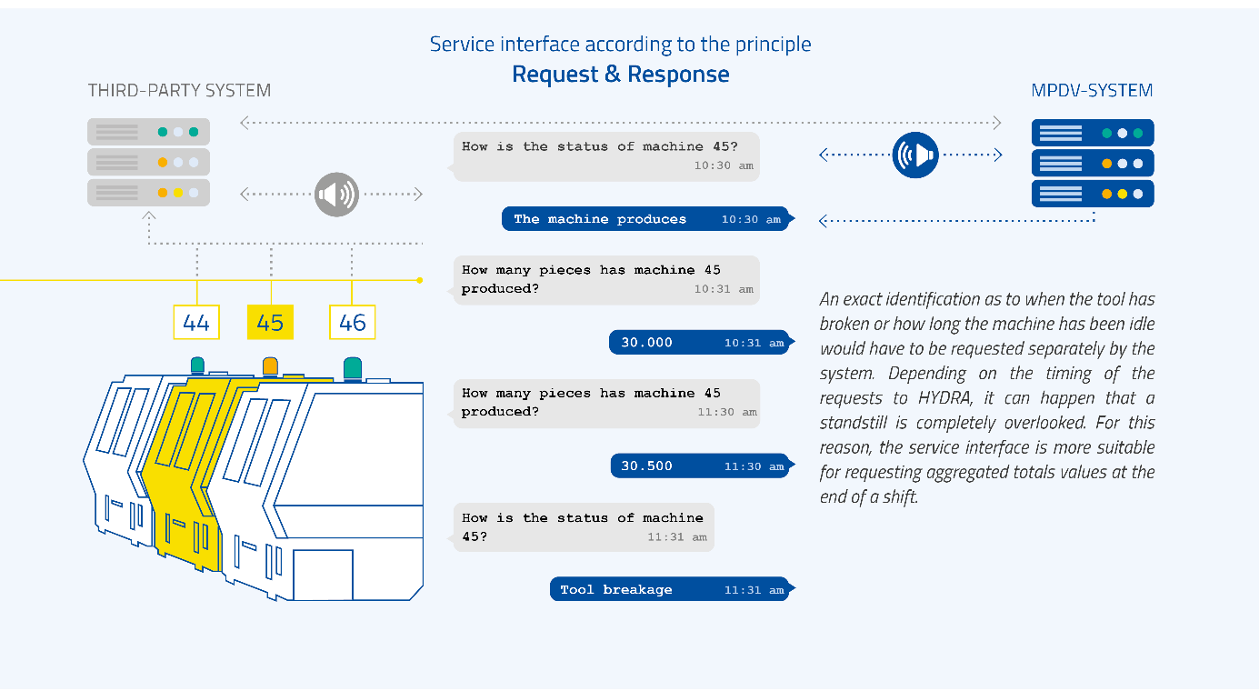
The new Factory Collaboration Hub is now available for communication between third-party systems and MPDV systems.

Image source: MPDV, Adobe Stock, markobe

Keywords
System communication, third-party systems, Factory Collaboration Hub, Manufacturing Execution System (MES), HYDRA, Manufacturing Integration Platform (MIP), Manufacturing IT, MPDV

About MPDV

MPDV, headquartered in Mosbach/Germany, is the market leader for IT solutions in the manufacturing sector. With more than 40 years of project experience in the manufacturing environment, MPDV has extensive expertise and supports companies of all sizes on their way to the Smart Factory. Products such as MPDV's Manufacturing Execution System (MES) HYDRA or the Manufacturing Integration Platform (MIP) enable manufacturing companies to streamline their production processes and stay one step ahead of the competition. The systems can be used to collect and evaluate production-related data along the entire value chain in real time. If the production process is delayed, employees detect it immediately and can initiate targeted measures. More than 800,000 people in over 1,250 manufacturing companies worldwide use MPDV's innovative software solutions every day. This includes well-known companies from all sectors. MPDV employs around 480 people at thirteen locations in China, Germany, Luxembourg, Malaysia, Singapore, Switzerland, and the USA. Further information: www.mpdv.com.

PR contact

MPDV Mikrolab GmbH Phone +49 6261 9209-0
Nadja Neubig Fax +49 6261 18139
Roemerring 1 n.neubig@mpdv.com
D-74821 Mosbach www.mpdv.com
Germany

