Fast process for Ni-based alloys
The reliability and efficiency of the state-of-the-art MonsterMill NCR is impressive

Date of publication: June 2020
Reference: PR-18-08 – Fast process for Ni-based alloys

Ni-based alloys - they withstand high thermal and mechanical loads, are extremely corrosion-resistant and are suitable for many possible applications. The other side of the coin: the machining process for these super alloys is extremely challenging. Fortunately, we now have the MonsterMill NCR end mill from CERATIZIT, which is more than a match for these materials.
Whether in the aerospace sector, the chemical industry or in energy technology – components made from Ni-based alloys are often used wherever high thermal and mechanical loads prevail. The special properties of these materials speak for themselves: they have excellent heat-resistance, are tremendously hard even at high temperatures and on top of that, are also extremely corrosion-resistant. At the same time, these are the properties that often push machinists and tools to their limits. Manufacturing facilities that use state-of-the-art machining processes can only remain process-secure and efficient by using tools that have been specially designed for this application.
A perfectly adapted end mill
The MonsterMill NCR from CERATIZIT is one such tool. The milling cutter was specifically developed to take the unpredictability out of working with this hard and high tensile material. Various factors ensure that the difficulties associated with machining Inconel and similar materials are a thing of the past. The MonsterMill NCR has a special tool geometry that is precisely tailored to machining Ni-based alloys. This is crucial, especially in relation to tool wear, and ensures stable and reliable processes. The reinforced core diameter and increasing tapered core effectively counteract tool wear as well, making it possible to achieve an impressive tool life.
Ultra-modern coating technology
Last but not least, we also have the innovative DRAGONSKIN coating to thank for the MonsterMill NCR’s excellent ability to resist abrasive Ni-based alloys. The coating is also a new development and has excellent heat stability, as well as tremendous wear resistance. Protected in this way, the MonsterMill NCR enjoys remarkably long machining times in a material that is feared by machinists because of its tensile strength and exceptional hardness.
Reliable and efficient
CERATIZIT introduced the MonsterMill NCR in response to the special requirements of machining Ni-based alloys. Having mastered this most challenging discipline, the NCR enjoys an impressive and above-average tool life and demonstrates maximum process security. Manufacturing companies where these materials have to be machined reliably and efficiently cannot do without a milling cutter like this.
The MonsterMill NCR is one of the highlights in CERATIZIT’s new Up2Date supplementary catalogue, and from May 2020 onwards, will be available from stock. Further information and product tests can be found on the homepage cuttingtools.ceratizit.com/de/de/ncr

Attachments:
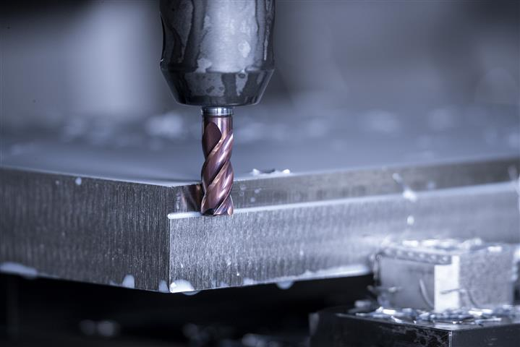
The MonsterMill NCR’s above-average tool life and high process security when machining Ni-based alloys is impressive

Published on behalf of

CERATIZIT Deutschland GmbH
Marketing \ Communications
Daimlerstraße 70 \ 87437 Kempten \ Germany
T. +49 831 57010-3405
F. +49 831 57010-3649
E. Norbert.Stattler@ceratizit.com

www.ceratizit.com

CERATIZIT – with passion and a pioneering spirit for hard materials
For over 95 years, CERATIZIT has been a pioneer in developing exceptional hard material solutions for machining and wear protection. The private company, with registered offices in Mamer, Luxembourg, develops and produces highly specialised cutting tools, indexable inserts, rods made from hard materials and wearing parts. The CERATIZIT Group is the global market leader in various application segments and successfully develops new carbide, cermet and ceramic grades, such as for wood and stone working.
With more than 8,000 employees at more than 30 production facilities and a sales network with over 50 branches, CERATIZIT is a global player in the carbide industry. The company’s international network includes subsidiary Stadler Metalle and joint venture CB-CERATIZIT.
The technology leader is continually investing in research and development and holds more than 1,000 patents. Innovative hard material solutions from CERATIZIT are used in various sectors, including mechanical engineering and toolmaking, in the automotive and aerospace industries and in the oil, gas and medical industries.

www.ceratizit.com \ www.kometgroup.com \ www.wnt.com \ www.klenk-tools.de

