Press release

TDM Systems: Continuous Growth with Sales Partners Worldwide
HAIMER Partners with TDM Systems to Offer Advanced Tool Management Solutions in South East Asia

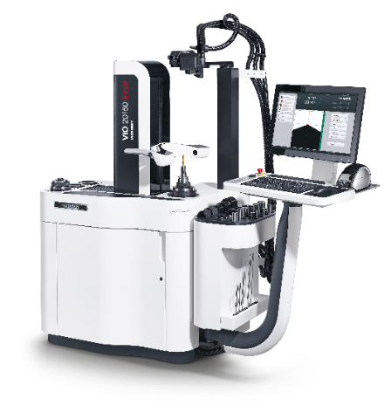
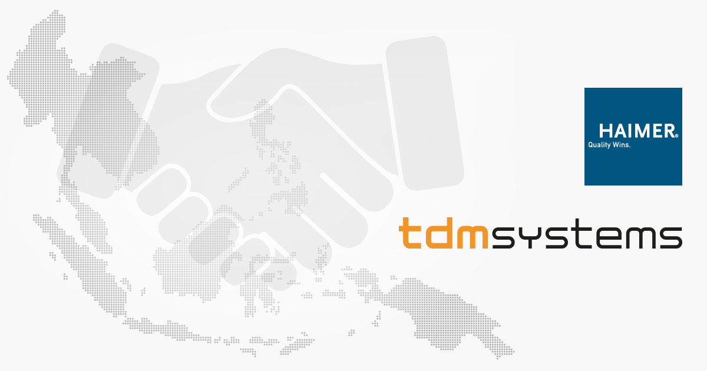

TDM Systems and HAIMER join forces to offer advanced tool management solutions in Southeast Asia. Image: TDM Systems
HAIMER equips its presetters in Southeast Asia with a TDM starter kit.
Image: TDM Systems

Tuebingen, Germany, March 10, 2021 - As part of the growth strategies of both TDM Systems and HAIMER in South East Asia, the two companies are joining forces to offer a one-stop-shop toolroom solution to machining companies in this prospering economic region.

In an effort to deliver the productivity and agility manufacturers need, and driving the digitalization in discrete manufacturing, HAIMER Asia Pacific Ltd. will offer TDM Systems’ tool management solutions. As a turn-key solution HAIMER presetters will be equipped with a TDM starter kit - a comprehensive package supporting smart manufacturing processes.
The goals are ambitious: a significant increase in sales in the coming years, a fast-growing customer base and first-class service in the prospering economic region South East Asia. To achieve these goals, Christian Kübel, Sales Director APAC at TDM Systems, is driving forward the global business development of the TDM solutions by expanding the partner network. And with HAIMER, one of the top-selling premium manufacturers of presetting equipment in the world, Kübel was able to sign up an important strategic sales partnership for TDM Systems to achieve these goals.
According to Kübel, HAIMER will, with their sophisticated and high-quality products, address "exactly those customers for whom a TDM solution is interesting." To ensure high customer satisfaction, HAIMER has maintained several sales and service offices in the region for years. "So, they know the country, the industry, the people and the language," says Kübel. The technical foundation of the partnership is the existing interface to HAIMER presetting devices which offers mutual customers enormous advantages.
For HAIMER, the cooperation is also promising. "Machining companies realize the greatest efficiency gains when they use our presetting devices together with TDM software. Therefore, we are pleased that we can now also actively offer this to our customers," emphasizes Amolak Singh, Managing Director at HAIMER SEA.
Since HAIMER and TDM Systems have already successfully implemented several joint projects in South East Asia, Kübel is certain that "HAIMER as a network partner will significantly push our sales in this region."
HAIMER, which has been part of the TDM partner network since 2020, will offer the TDM solution in Thailand, Vietnam, the Philippines, Indonesia, Singapore and Malaysia with immediate effect.
HAIMER will install the TDM solution on site at its technology centers for presentation purposes as part of the partnership. This will create great awareness among HAIMER's customers, Kübel is certain. In addition, HAIMER will equip its presetters in the countries mentioned with a TDM starter kit. This joint overall package is the "start into a holistic solution in the field of digital tool management for the customers”, says Kübel.
Smart manufacturing technologies such as a tool management systems offer great benefits, but it takes more than choosing the right technology - choosing the right partner ultimately helps to get maximum results and productivity increases for the end customer.

Print-quality images are available via the following link:
http://archiv.storyletter.de/download/xxxxxxx http://archiv.storyletter.de/download/Images_TDMSystems_HAIMER.zip

Your contact person:

Sandra Müller (formerly Schneck)

Telephone +49 (0) 7071 9492 1173
sandra.schneck@tdmsystems.com

TDM Systems GmbH
A member of the Sandvik Group
Derendinger Strasse 53
72072 Tübingen, Germany
https://www.tdmsystems.com/en/

Agency contact:

Mara Ebinger

Telephone +49 (0) 7071 9387 2159
m.ebinger@storymaker.de

Storymaker GmbH
Derendinger Strasse 50
72072 Tübingen, Germany
https://www.storymaker.de/

About TDM Systems
For over 25 years, TDM Systems GmbH, Tübingen has been the leading provider of Tool Management solutions in the area of machining. With the Tool Lifecycle Management strategy, TDM Systems is focusing specifically on process optimization through optimal tool planning and provisioning. Creating and editing tool data and graphics, integrating tool expertise and 3D graphics into the CAM engineering, and organizing the complete tool circulation at the shop-floor level are the three core competencies of TDM Systems and the pillars of the TLM strategy. As a member of the Sandvik Group, TDM Systems draws on the expertise of various tool manufacturers when developing its software products.

www.tdmsystems.com

