HEIDENHAIN at interlift 2019: encoders for elevators of the future

In the near future, cable-based elevator technology will no longer need microswitches for brake release monitoring. That’s because the new HEIDENHAIN KCI 419 Dplus rotary encoder for elevators provides not only position feedback for elevator motor control but also additional data for brake monitoring. In the more distant future, elevators will even run without cables. At interlift 2019, HEIDENHAIN will be showcasing an encoder solution for this as well: the LINA 200 absolute linear encoder.

The KCI 419 Dplus rotary encoder for elevators: intelligent integration of position feedback, brake release monitoring, and temperature monitoring
At interlift 2019, HEIDENHAIN will introduce you to the elevator rotary encoder of the future. In addition to providing motor feedback, the new KCI 419 Dplus considerably enhances availability and safety by monitoring the safety brake and temperature. It also features comprehensive online self-diagnostic functionality. Currently needed microswitches will disappear, along with the cost and effort of mounting, wiring, adjusting, and maintaining them.

In addition to transmitting rotational position values, the KCI 419 Dplus inductive rotary encoder for elevators also measures axial motion. When mechanically coupled with the brake’s armature plate, the KCI 419 Dplus can detect the brake stroke. Based on this information, the subsequent electronics can determine the state of the brake (released or engaged) and the amount of brake wear. By virtue of its direct proximity to the motor and brake, the KCI 419 Dplus elevator rotary encoder also provides meaningful temperature monitoring data without the need for additional sensors. These temperature data can then be used to infer the presence of malfunctions.

Because all of these parameters are transmitted on a single cable via the purely digital EnDat 2.2 interface, overall system cabling is greatly simplified. Further benefits include improved remote monitoring and predictive maintenance capabilities. In addition to these completely new innovations, the KCI 419 Dplus also includes all of the familiar strengths of classic rotary encoders from HEIDENHAIN. Its inductive scanning method is highly immune to contamination and vibration, and is renowned for its operational reliability.

The LINA 200 absolute linear encoder: HEIDENHAIN encoder technology for cableless elevators of the future
Envision an elevator car not pulled by cables while capable of both vertical and horizontal travel—HEIDENHAIN is offering the encoder technology to make this possible. The LINA 200 absolute inductive linear encoder features two tracks with differing signal periods from which an absolute position value is calculated.

Rather than lying in the same plane, these tracks are designed to face each other. The resulting U-shaped scale allows the measuring standard to be scanned from two sides. At the same time, a double-wall design protects both the graduation and the scanning process from mechanical and electromagnetic interference. This structural configuration also combines maximum stiffness with low weight. What’s more, the U-shaped design provides significant benefits for the mechanical sturdiness of the scale and the robustness of the encoder signals.

Possessing an overall length of 2400 mm, the graduation carrier of the LINA 200 is mounted to the elevator car. It consists of four segments, each with a measuring length of approximately 600 mm. These segments are read by cascaded scanning heads mounted inside the shaft, thus permitting continuous position feedback over the entire travel distance. Even with its generous guideway tolerances of ±5 mm and ±4 mm, the LINA 200 still attains a tiny measuring step of approximately 2 µm. It thus delivers reliable, highly accurate position feedback for the cableless elevator’s motor control. Yet it also provides sufficiently wide tolerances for real-world mounting inside the elevator shaft and for the compensation of building displacement.

LINA 200: reliable data transmission via EnDat for high dynamic performance and passenger comfort
Developed specifically for cableless elevators, the LINA 200 boasts excellent performance data when it comes to dynamics and passenger comfort. Traveling speeds of 6 m/s were easily attained during initial testing, and in a laboratory setting, the LINA 200 provided reliable position feedback at speeds of up to 18 m/s. At low speed, as well as during the deceleration and acceleration phases before and after a stop, the high-resolution position feedback (18 bits) at a measuring length of approximately 600 mm ensures very comfortable and gentle motion.

The scanning head signals are so robust and reproducible that the diagnostic values for signal quality defined in the EnDat protocol can also yield information about whether the guide rails are within tolerance. The LINA 200 thus serves not only as a linear encoder but also provides data for continuous diagnostics and condition monitoring of the larger mechanical system. As a result, lateral deviations during operation can be detected.
The high-accuracy position values are transmitted purely digitally to the subsequent electronics via the EnDat 2.2 interface. In this particular application, however, EnDat 2.2 provides another important and safety-relevant benefit pertaining to the strong magnetic fields that surround linear motors: the EnDat 2.2 interface features high electromagnetic compatibility and, unlike conventional analog signals, ensures reliable data transmission even in this kind of environment.

HEIDENHAIN at interlift 2019: Hall 5, Booth 5099

For more information, visit:
www.heidenhain.de

Contact person for the trade press:
Frank Muthmann
DR. JOHANNES HEIDENHAIN GmbH
83292 Traunreut, GERMANY
Tel.: +49 8669 31-2188
muthmann@heidenhain.de

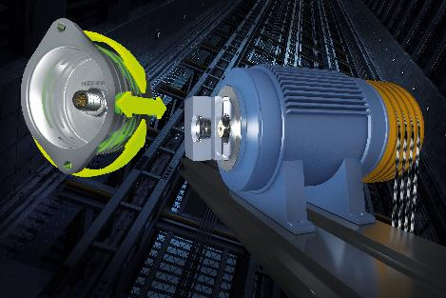 | Two-dimensional measurement is now a thing of the past: the new KCI 419 Dplus elevator rotary encoder delivers position feedback, axial distance data for brake release monitoring, and temperature data for brake monitoring.
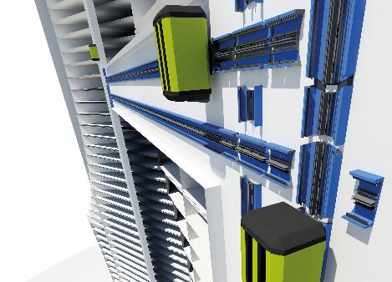 | Cableless elevators feature high flexibility: multiple cars can be moved vertically within a single elevator shaft, and even horizontal movement is possible.
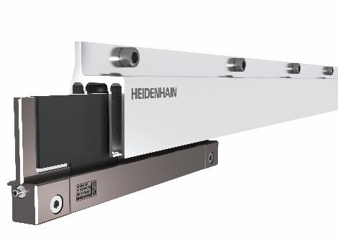 | The new LINA 200 linear encoder for cableless elevator technology: above, the U-shaped scale, which is mounted to the elevator car; and below, the scanning head for mounting in the elevator shaft.

