Marposs’ New Smart Factory SW: the best choice for responsible production

To provide data evidence for decisions and assist in the optimization of a factory, Marposs is introducing its new Smart Factory SW.
For over 10 years, Marposs’ C-THRU4.0 has shown its capabilities to improve the machining process, avoid scrap and provide quality evidence for the components.
The new suite maintains the C-THRU4.0 name, but is otherwise completely new -- intuitive, web-based and with new features. It consists of a suite of modules, with each specializing on one aspect of a factory.
There are five modules, each oriented to help the production responsible and/or engineers:
- C- Analyze is designed to optimize the work of the machines (process, setup, lines, quality problems), to provide traceability of the process and for predictive maintenance.
- C-Tooling is to optimize the tooling, including the tool life, usage and choice.
- C-OEE is meant to prioritize and analyze the causes of production loss, mostly productivity and machine up time.
- C- Energy is the tool used to monitor and optimize the energy consumption of all equipment in a factory, also designed for the fulfilment of ISO 50001:2018.
- C-Probe enables centrally reads the measurements of the touch probes and sets limits to verify the results of the machining of the whole shop floor.
This is a unique suite of SW tools directed to the technical personnel of a factory designed to highlight process anomalies, which uses a friendly graphic interface to identify and choose ways to optimize. This reiterative process leads to an increase in the efficiency of a factory in each of the module areas.
Other advantages of the SW are that it provides factory insight, and the verification of the effectiveness of improving measures and benchmarks against the past or between lines, machines, and shifts.
For more information, visit us at our stand at EMO (Hall 6, Stand B52) or visit our website: https://www.marposs.com.

About Marposs
MARPOSS was founded in 1952 and Mr. Stefano Possati is the President of the Group; it provides shop-floor solutions for measurement, inspection and testing in the production environment. Marposs’ solutions include gauging equipment of mechanical components, before, during and after the production process; monitoring solutions on machine tools; assembly and testing for many industry sectors; and automatic machines and inspection stations for production lines. MARPOSS is one of the main suppliers to the automotive industry providing solutions for both traditional and electric mobility but additionally operates in the aerospace, biomedical, hi-tech, white appliance, and glass containers industries. MARPOSS Group employs 3500 people around the world and is present in 34 countries with more than 80 sales offices.

Characters with spaces: 1.901.

Caption: C-THRU4.0: a completely new suite with five modules for responsible production processes.

Contact
Marposs S.p.A.
Martina Battilani
Via Saliceto, 13
40010 BENTIVOGLIO (BO) - ITALY
Phone: +39 051 899 719
Fax: +39 051 899 525
E-Mail: martina.battilani@marposs.com

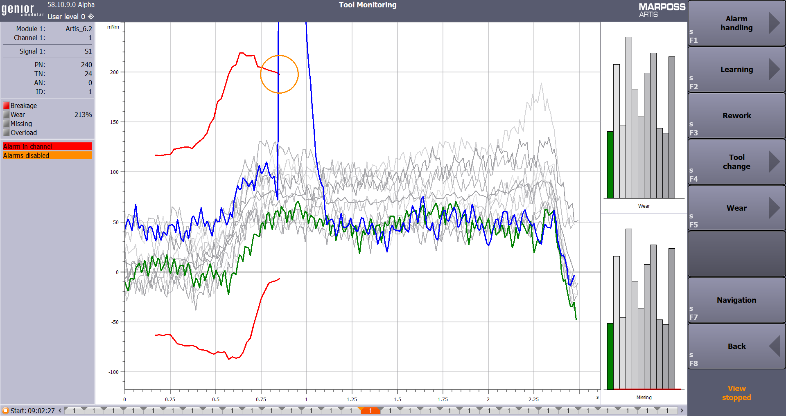

Image description: C-THRU4.0.jpg -> C-THRU4.0, the completely new software suite by Marposs.

