NVH G-EAR
Noise Testing Of Individual Gears

The EMO 2023 will offer its scene to Marposs presenting one of its most recent developments in the area of gear measurement and testing: the NVH G-EAR machine.

With the now firmly established growing trend towards hybrid (HEV) and full electric vehicles (EV), the noise of the drivetrain has become one of the major issues that every car manufacturer has to deal with. In BEVs, a silent gearbox not only ensures the mechanical reliability and efficiency of the electric drive unit, but also represents a comfort issue for the driver.

To achieve the target of a silent gearbox, it is paramount to test 100% each individual gear prior to the assembly of the transmission or gear reducer. The identification of potential noisy gears at this stage represents a huge time and cost saving for our customers.

The ideal solution for gear noise testing in a manufacturing environment is Marposs NVH G-EAR, a machine that is capable to test the parts at challenging operating conditions (3000 rpm rotation speed, 40 Nm torque) using a special master gear that engages the part based on the Single Flank rolling action.

Visitors can see a 3D interactive reproduction of the application on a touchscreen large monitor at the Marposs booth, counting on the support of our experts introducing the system and answering any specific question.

For more information, visit us at our stand at EMO (Hall 6, Stand B52) or visit our website: https://www.marposs.com.

About Marposs
MARPOSS was founded in 1952 and Mr. Stefano Possati is the President of the Group; it provides shop-floor solutions for measurement, inspection and testing in the production environment. Marposs’ solutions include gauging equipment of mechanical components, before, during and after the production process; monitoring solutions on machine tools; assembly and testing for many industry sectors; and automatic machines and inspection stations for production lines. MARPOSS is one of the main suppliers to the automotive industry providing solutions for both traditional and electric mobility but additionally operates in the aerospace, biomedical, hi-tech, white appliance, and glass containers industries. MARPOSS Group employs 3500 people around the world and is present in 34 countries with more than 80 sales offices.

Characters with spaces: 1.420.

Caption: Marposs NVH gear tester is able to detect macro-geometry and micro-geometry defects that are responsible for gear whine and noise phenomena.

Contact
Marposs S.p.A.
Martina Battilani
Via Saliceto, 13
40010 BENTIVOGLIO (BO) - ITALY
Phone: +39 051 899 719
Fax: +39 051 899 525
E-Mail: martina.battilani@marposs.com

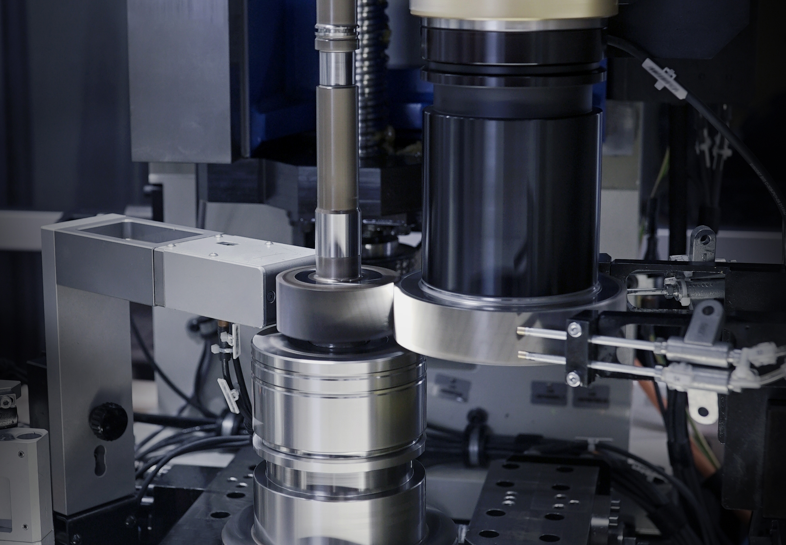
Image description: NVH G-EAR.png -> Marposs NVH gear tester

