HEIDENHAIN at EMO 2023: reliably inspect workpieces with the new generation of METRO and SPECTO length gauges

Workpiece inspection is very important both during and after machining. The new generation of METRO and SPECTO length gauges from NUMERIK JENA provides production metrology and quality inspection with many benefits that ensure the delivery of perfect products to customers.

A new generation of length gauges is premiering at EMO 2023, complete with a new brand image. The METRO and SPECTO gauges now run under the brand NUMERIK JENA. This member of the HEIDENHAIN Corporate Group has applied its expertise in compact measuring devices and miniaturization to redesign the length gauges. The new models are much slimmer, enabling a significant reduction in overall station width. This opens up new horizons for multi-gauging fixture design, including a greater number of measuring points.

Versatility was a high priority while developing the new generation of length gauges. Their standardized platform design with multiple variants provides an adaptable modular system able to meet nearly any requirements in production metrology, quality assurance, measuring equipment monitoring and position measurement. Customers can select the characteristics they need:
- Accuracy grade: ±0.5 µm (METRO) or ±1.0 µm (SPECTO)
- Measuring length: 12 mm or 30 mm
- Shaft diameter: standardized at 8 mm for both measuring lengths
- Connector outlet: axial or radial
- Plunger actuation: pneumatic or spring-loaded
- Communication interface: 1 V_{PP} or TTL
The mutual mounting compatibility of the new METRO and SPECTO length gauges, and thus the possibility of using different variants in a single application, increases versality during the initial setup of a measuring station and facilitates adaptations within existing setups while reducing cost and effort. Further benefits include robustness and consistently high accuracy across the entire measuring range, resulting in high measurement reliability.

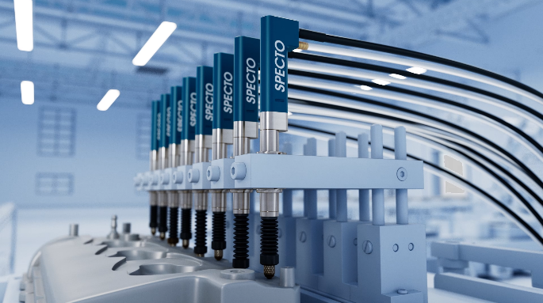 | The new generation of METRO and SPECTO length gauges from NUMERIK JENA: high versatility for nearly any requirements in production metrology, quality assurance, measuring equipment monitoring and position measurement.

For more information, visit:
live.heidenhain.com
www.heidenhain.com/tnc7
www.heidenhain.com

Contact persons for the trade press:  Frank Muthmann  DR. JOHANNES HEIDENHAIN GmbH  Dr.-Johannes-Heidenhain-Straße 5  83301 Traunreut, GERMANY  Tel.: +49 8669 31-2188  muthmann@heidenhain.de | Ulrich Poestgens  DR. JOHANNES HEIDENHAIN GmbH  Dr.-Johannes-Heidenhain-Straße 5  83301 Traunreut, GERMANY  Tel.: +49 8669 31-4154  poestgens@heidenhain.de

