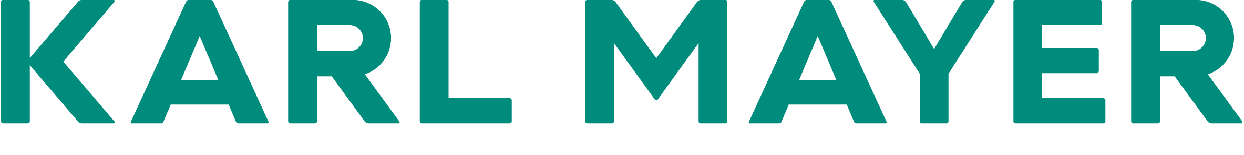

Presseinformation / press release  Postanschrift / post address:  KARL MAYER GROUP  Industriestraße 1  63179 Obertshausen | Mediakontakt / media contact:  Ulrike Schlenker  Tel.: +49 6104/402-274  E-Mail: ulrike.schlenker@karlmayer.com
Nummer / number: 2518 | Datum / date: 11.03.2025

KARL MAYER wins trademark dispute
Strong defence secures the trademark rights for PROWARP, KARL MAYER PROSIZE and PRODYE

KARL MAYER’s textile machines are renowned for their outstanding quality, efficiency and dependability, ensuring the high level of performance customers expect. As a global market leader, the company has registered trademarks for many of its innovative products, including PROWARP for its sectional warping machine in 2015, KARL MAYER PROSIZE for its sizing machine in 2012 and PRODYE for its indigo dyeing unit in 2018.
The strong reputation of KARL MAYER’s successful warp preparation brand family has led to copycat activity, prompting the company to take legal action in Turkey. After a lengthy court case, KARL MAYER ultimately prevailed when it was ruled that the competitors, Proteknik Tekstil San. ve Dıs Tic. A.S. and Prosmh Makina Pazarlama Sanayi ve Ticaret Anonim Sirketi, had exploited these trademarks for unfair gain. A cease-and-desist letter had failed to put an end to the ongoing infringement, but with effect from 12 December 2024, a regional court ruling upheld KARL MAYER’s case. This prohibits the commercial use of the contested terms in relation to the manufacture, sale, packaging, storage and distribution of competing machines. The restriction applies across the full scope of the trademark rights, covering Turkey as well as all online activities.
KARL MAYER’s perseverance has ultimately paid dividends.
“We invested a great deal of money and pursued legal action for nearly seven years to protect not only our proprietary technology, but also our customer and reputation,” explains Martin Fuhr, Head of Product Portfolio Management, Business Unit Warp Preparation at KARL MAYER.

Innovations worth protecting
Cutting-edge solutions designed for maximum customer benefit are central to the world market leader’s success. In the last year alone, two major innovations were introduced for the PROSIZE, including the CASCADE system, which lowers the sizing machine’s steam consumption by up to 7%. The Smart Size Box uses sensors and digital solutions to monitor the condition of wear components, making a valuable contribution to predictive maintenance. In addition, the size box ensures optimal sizing application, needs less size add-on - a saving of up to 10% can be achieved here - and the yarn is wound extremely gently onto the warp beams.
PROWARP with PROACTIVE Warping demonstrates how modern sensor technology and digital solutions transform quality into a real competitive edge. This cloud-based system ensures exceptionally high reproducibility of warping results, top-tier warp quality and unique benefits in the weaving process.
The innovative core of PRODYE is a specialised dyeing vat. Its optimised design allows for deeper indigo tones using fewer boxes and a reduced dye bath volume compared to conventional systems. An advanced circulation system and enclosed vat construction also reduce hydro and caustic soda consumption by up to 20%.
These are just some of the ways KARL MAYER is shaping the future of textile technology.

