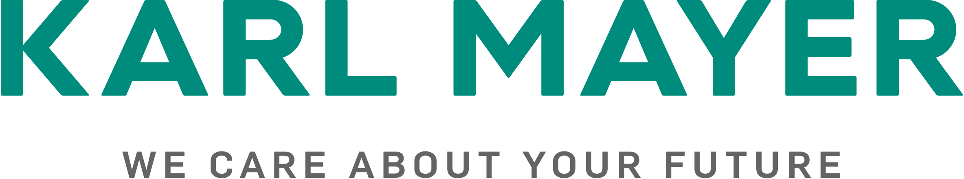

Presseinformation / press release  Postanschrift / post address:  KARL MAYER  Verwaltungsgesellschaft SE  Industriestraße 1  63179 Obertshausen | Mediakontakt / media contact:  Ulrike Schlenker  Tel.: +49 6104/402-274  E-Mail: ulrike.schlenker@karlmayer.com
Nummer / number: 2522 | Datum / date: 15.04.2025

High-performance machines for Warp Knitting and Warp Preparation in North America
KARL MAYER showcases its innovations in the German Pavilion at Techtextil North America 2025

KARL MAYER will presen innovative solutions for warp knitting and warp preparation for the technical textiles industry at Techtextil North America, from May 6 to 8, 2025. At the German Pavilion, in Hall B of the Georgia World Congress Center in Atlanta, visitors will find a dedicated team, video presentations and materials on machine topics focused on the North American market: the HKS 3 M-ON high-performance warp knitting machine, the PROWARP automatic sectional warping machine and the WEFTTRONIC® II RS high-performance Raschel machine with weft insertion.
Mariano Amezcua, President of KARL MAYER North America, is looking forward to a lively trade fair: “There’s nothing like the energy of reconnecting face-to-face at Techtextil – being able to engage directly with our customers, showcase real-world applications, and spark conversations around future growth is both inspiring and invaluable.”

Highlights from the KARL MAYER presentation
The HKS 3 M-ON offers the latest technology for highly efficient and precise production of tricot fabrics - the most important market for KARL MAYER warp knitting machines in North America. Models with three guide bars are the most widely used machines in this market. The HKS 3 M-ON combines maximum flexibility with speed and a competitive price, thus ensuring a performance that is expected to generate great interest among Techtextil visitors.
The WEFTTRONIC® II RS is also well-established in the US market for technical textiles. Manufacturers of coating substrates for industrial roofs rely on the cost-effective and reliable Raschel machine with course-orientated weft insertion which boasts considerable capacities. Geotextiles are another lucrative application area for the WEFTTRONIC® II RS. The KARL MAYER team will have an extensive collection of samples at their disposal and look forward to a lively exchange of ideas.
The PROWARP has great potential in North America. It is the ideal machine for investments in capacity expansion and productivity improvements. The automatic sectional warper processes all types of materials and is equipped with the latest connectivity, measurement and control technology. The PROACTIVE warping system, in particular, is sure to attract attention.
The system records the warp quality of the sectional warper and features a three-stage modular structure for diverse information requirements. Each expansion level provides more detailed quality data and production information. Module 1 manages all the basic values supplied by the warper sensors for direct beaming quality. Module 2 supplements these values with optical evaluations of a machine-integrated camera to obtain specific information on band width, alignment and parallelism. Module 3 provides quality protocols with the highest information density. Creel monitoring data and individual yarn tension values from MULTIGUARD are also included in the records.

