PRESS RELEASE

ANDRITZ collaborates with Tandem Repeat on solutions to produce novel sustainable fiber
GRAZ, OCTOBER 24, 2025. International technology group ANDRITZ has entered into a collaboration with Tandem Repeat Technologies, a pioneering biotechnology company, to bring to the market industrial-scale solutions for producing ProcellTM, a new sustainable fiber for textiles and nonwovens.

The collaboration brings together Tandem Repeat’s expertise in advanced biotechnology and ANDRITZ’s extensive experience as a supplier of solutions and plants for the production of nonwovens and manmade cellulosic fibers. The two companies aim to support the textile industry’s transition toward more sustainable production and alternatives to conventional synthetic fibers.

Procell, developed and patented by Tandem Repeat, is a biomanufactured fiber made from proteins. Its wool-like softness, exceptional strength, durability, and versatility make it well-suited for a broad range of applications.

The partners will focus on offering industrial-scale solutions for fiber manufacturers in the textiles and nonwovens sectors to produce Procell. These solutions will utilize ANDRITZ’s proven process equipment, adapted to the specific requirements of Procell, while Tandem Repeat will partner on the development of Procell technology.

Dr. Sergey Malkov, VP Manmade Cellulosic Fibers at ANDRITZ, said: “We are pleased to collaborate with Tandem Repeat on this exciting product. Procell fiber has the potential to be a true breakthrough in sustainable materials.”

Dr. Melik Demirel, co-founder of Tandem Repeat, added: “By partnering with ANDRITZ, we can bring our revolutionary fiber to market on a commercial scale. This will support industries in achieving sustainable production and supply chain resilience.”

– End –

ANDRITZ AG ⁄ Stattegger Strasse 18 ⁄ 8045 Graz ⁄ Austria ⁄ p: +43 316 6902-0 ⁄ welcome@andritz.com ⁄ andritz.com

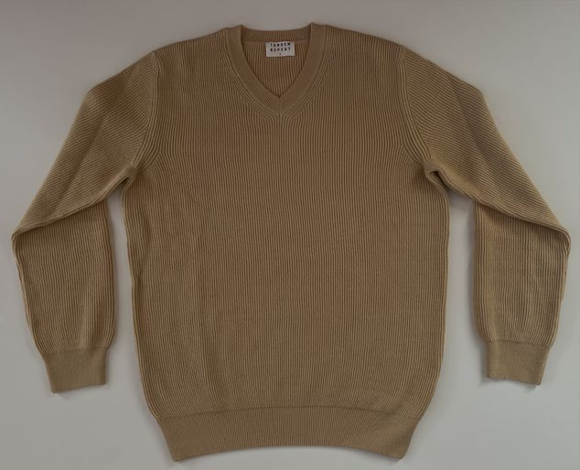
Garments made of fibers developed by Tandem Repeat

PRESS RELEASE AND IMAGE AVAILABLE FOR DOWNLOAD
The press release and image are available for download at andritz.com/news. The image may be published free of charge if the source is stated: “Image: Tandem Repeat”.

FOR FURTHER INFORMATION, PLEASE CONTACT
Niklas Jelinek Media Relations
niklas.jelinek@andritz.com andritz.com

ANDRITZ GROUP
International technology group ANDRITZ provides advanced plants, equipment, services, and digital solutions for a wide range of industries, including pulp and paper, metals, hydropower, environmental, and others. Founded in 1852 and headquartered in Austria, the publicly listed group employs about 30,000 people at 280 locations in over 80 countries.
As a global leader in technology and innovation, ANDRITZ is committed to fostering progress that benefits customers, partners, employees, society, and the environment. The company’s growth is driven by sustainable solutions enabling the green transition, advanced digitalization for highest industrial performance, and comprehensive services that maximize the value of customers’ plants over their entire life cycle. ANDRITZ. FOR GROWTH THAT MATTERS.

TANDEM REPEAT TECHNOLOGIES, INC.
Tandem Repeat Technologies, Inc. is a pioneering biotechnology company based in Philadelphia, PA, dedicated to developing sustainable, high-performance fibers and textiles from bio-engineered proteins. Tandem Repeat leverages its expertise in genetic sequencing and bio-manufacturing to develop materials for diverse applications, from high-end fashion to military-grade protective textiles. The company is committed to creating a transparent, circular, and sustainable ecosystem for the fashion industry, driving the global shift toward a bio-based, climate-positive future. Its mission is to be the global leader in climate-positive material solutions for the textile, packaging, and construction industries.
Media & Press
Reach us at media@tandemrepeat.com

