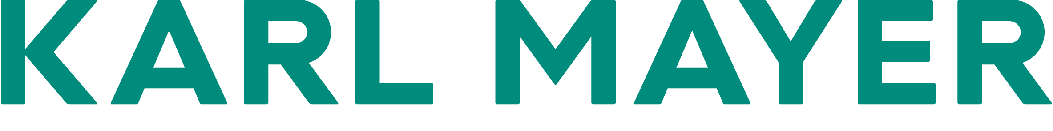

Presseinformation / press release  Postanschrift / postal address:  KARL MAYER  Verwaltungsgesellschaft SE  Industriestraße 1  63179 Obertshausen  Germany | Mediakontakt / media contact:  Ulrike Schlenker  Tel.: +49 6104/402-274  E-Mail: ulrike.schlenker@karlmayer.com
Nummer / number: 2544 | Datum / date: 12.11.2025

Getzner Textil steams ahead with energy savings
CASCADE by KARL MAYER leads to significant energy savings when used in the PROSIZE at Getzner Textil

Getzner Textil AG is always open to new ideas and committed to investment in innovative technological solutions. This has proven a highly successful approach for more than two hundred years now: founded in 1818 as a family business in Bludenz in the heart of Europe, the company is now one of the world’s leading manufacturers of fabrics for African fashion, shirts and blouses, corporate fashion, and technical textiles, with 1,550 employees, 710 weaving machines, seven locations, and an output of 73 million running meters per year.
It was only in the autumn of 2024 that Getzner installed a new PROSIZE staple fibre sizing machine by KARL MAYER in its warp preparation department. The sizing machine was delivered with the then newly launched CASCADE and raised expectations of greater sustainability and lower energy costs – and justifiably so, as the results of tests carried out during machine operation in August this year showed. The tests confirmed savings in steam consumption of up to 3.9% thanks to the steam and condensation system over a representative period of time. Peaks of up to 7% were measured at times.

Verifiable benefits
CASCADE recirculates part of the process steam produced during drying in cylinder dryers, enabling genuine, efficient energy recycling within the machine. Specific data on the recycling volumes achievable in practice was gathered in tests carried out at Getzner Textil in Bludenz. The tests looked at a drying line with ten cylinders during one shift and the production of seven weaving beams. The last four cylinders of the systems had been operating with a mixture of recycled flash steam from the first six cylinders and live steam. The respective supply quantities of recycled steam were measured. The results prove CASCADE’s effectiveness. At full machine load, 51 kg/h of the total 1,295 kg/h of steam required was obtained directly through the inline recycling of the CASCADE system.
As plant utilization declined, the potential savings in fresh steam decreased, but even at low-capacity utilization, reduction effects were evident. These are also influenced by the recipe, i.e., the process conditions. The following applies: the greater the temperature difference between the first and second cylinder sections, the greater CASCADE’s efficiency.
CASCADE thus opens up potential that can always be exploited without restrictions on the recipe. However, the magnitude of this potential can be influenced – unlike, for example, the eco mode in a car, which reduces performance and acceleration once activated.

Significant savings potential
The lower live steam consumption enables cost savings and a reduced carbon footprint. At full machine and production utilization – three-shift operation, 5,000 hours/year, 83% efficiency – and a steam price of €40/t, a cost reduction of around €8,500/year can be achieved under the representative practical conditions at Getzner Textil. In addition, in this specific example, it was possible to reduce the company’s environmental impact by 59 tons of CO2e/year.
Given the common practice of feeding condensate that is usually too hot for use in the boiler house back into the operating network, thereby losing thermal energy, every contribution from CASCADE pays off. For all customers who operate the feed water tank in the boiler house without pressure, any excess energy above a condensate temperature of 100°C is lost when it is fed back into the company’s own media network. The white steam clouds rising from the boiler house are a visible sign of this. With CASCADE, operators can minimize this loss of power without additional investments in machine peripherals.

