New SW machining center: maximum productivity in the minimum space
Two-spindle BA W02-22 with wear-free direct drive technology shortens cycle times in precision mechanics
Schramberg, 05.10.15. Equipped with linear and torque motors in all feed axes, the new two-spindle BA W02-22 machining center from Schwäbische Werkzeugmaschinen GmbH (SW) is setting new records for short cycle times and unparalleled precision in 5-axis machining. With a spindle distance of 250 mm, the extremely compact machine manufactures complex workpieces of non-magnetic materials highly efficiently on an installation area of barely four square meters.

"Wear-free direct drive technology features significantly shorter cycle times and higher availability, which in turn ensures the lowest Total Cost of Ownership," notes Reiner Fries, Managing Director of Sales at SW. The leading provider of multi-spindle machining centers for medium and large-size series developed the new BA W02-22 especially for precision mechanics applications, for example in the watchmaking industry or automotive sector. They are well suited for the high-precision free-form machining of impellers required in these applications.

Chip-to-chip in 1.75 seconds

The linear feed axes accelerate at up to 24 m/s² to a rapid traverse speed of up to 120 m/min. The liquid-cooled HSK A40 motor spindles with AC synchronous technology can reach the maximum speed of 25,000 rpm in just 0.7 seconds. The chip-to-chip time for a tool change is just 1.75 seconds. Loading and unloading are in parallel to machining time, via the double swivel carrier. For this purpose, SW has integrated two independent planetary tables driven by torque motors and equipped with direct angular measurement. If necessary they can be fitted with integrated hydraulic workpiece clamping systems.

Doubled Kv factor shortens cycle times

Compared to ball screws, the BA W02-22 with direct drive technology achieves twice as high a Kv factor and a wear-free jerk of 1200 m/s³ for high-precision micro-movements. "Due to the extremely low weight of the planetary axes, the high dynamics and short auxiliary times, our smallest family member reduces the cycle time in comparison to conventional machines by a two-digit percentage," emphasizes Reiner Fries.

Even at high machining speeds, the compact machine achieves a positioning accuracy of less than 0.006 mm. The electronically coupled gantry drive for the Y-axis also contributes to this accuracy. It ensures high positioning accuracy, even with eccentric loads. The practically complete weight compensation in the vertical axis increases energy efficiency and reduces thermal stress on the feed motors. The 3-axis unit is designed as a "box-in-open-box" with very small and low-mass machining units. The SW-specific design provides free access for service and maintenance tasks from the rear of the machine. The tool magazine, protected against swarf and spray water, can be loaded directly from the workstation and is modularly expandable to hold 40, 80 or 120 slots.

The new two-spindle machining center with linear motors from SW – currently the smallest of its kind – ensures finely scaled coverage of spindle distances of 250, 400, 600 and 800 mm.

Contact person:
Schwäbische Werkzeugmaschinen GmbH
Seedorfer Straße 91
78713 Waldmössingen
Stefanie Moosmann
Telefon: +49 7402 74-255
Fax: +49 7402 74-258
s.moosmann@sw-machines.de
The following, high-resolution pictures are attached to the press release. These may be used for editorial purposes. Provided that you specifiy the reference „Photo: Schwäbische Werkzeugmaschinen GmbH“ and you send a free voucher copy to the above address they can be used, free of charge.
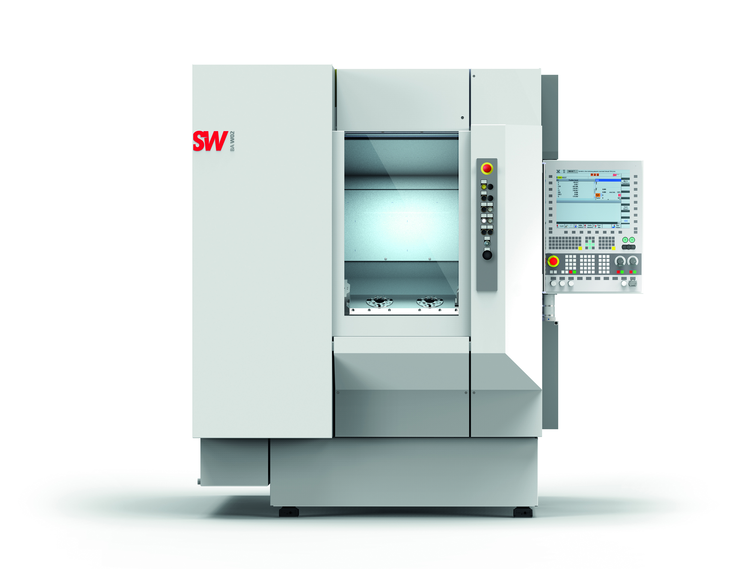 | High precision machining of small parts with the new twin-spindle machining center BA W02-22
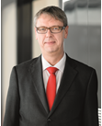 | Managing Director Sales: Reiner Fries

A short information about Schwäbische Werkzeugmaschinen GmbH:
Schwäbische Werkzeugmaschinen GmbH, or SW, in Waldmössingen is an expanding manufacturer of internationally successful production systems in the metal-working industry. Currently about 470 employees develop and plan machine tools and accessories.
For more information click www.sw-machines.de

