AMB PREVIEW - Hall 2, Booth A-31

PRESS RELEASE
Press photos available
BIG KAISER to unveil next-generation digital boring heads with wireless connectivity at AMB

Ruemlang, Switzerland – August 24, 2016 – BIG KAISER, a global leader in premium high-precision tooling systems and solutions, will showcase its industry-leading portfolio of high-precision boring tools and tool holders at AMB in Stuttgart, Germany, September 13 to 17, 2016.

Product Innovations not to be missed at AMB

- EWD EVO - next-generation digital boring heads with wireless connectivity for mobile devices, enabling operators to monitor cutting data on their smartphones and tablets
- Next-generation Smart Damper: New anti-vibration boring bar for turning machines and roughing tasks
- World’s first super-slim hydraulic chuck for HSK-E25 machine spindles – completes the extensive range of BIG KAISER hydraulic chucks
- MEGA25N - High precision collet chuck for cutting tools with a shank diameter of 25 mm
- Angle head “Center-Through Type” with coolant fed through the spindle
- New cutting data app leads you conveniently to the cutting data you need
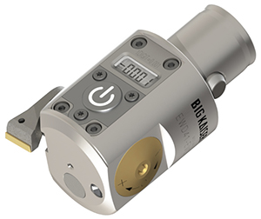 | 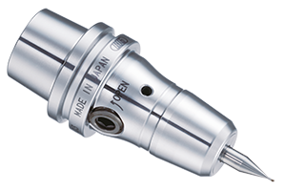 |  |  | 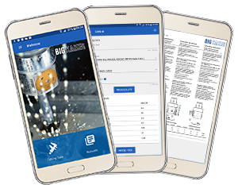
Digital leadership
As the trendsetter in digital design, BIG KAISER has taken the lead and invested into an in-house facility for the production of digital displays and direct electronic measuring systems. "Our in-house competence in electronic design positions us perfectly to take advantage of future opportunities,” says Peter Elmer, CEO of BIG KAISER Precision Tooling.

Higher Performance Guaranteed
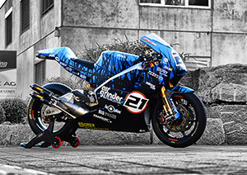 |  | As an official technology partner of Swiss motorbike manufacturerer Suter Racing, BIG KAISER will also be exhibiting the Suter MMX 500 motorcycle, which competed at this year's International Isle of Man TT (Tourist Trophy) Race - the most prestigious and most grueling motorcycle race on the face of the earth, and the ultimate test for competitors and machines alike. See this motorcycle, delivering an impressive 200 hp at a weight of only 130 kg, precision-built utilizing BIG KAISER technology.
Visit BIG KAISER located in Hall 2, Booth A-31, and experience first-hand the high quality and precision of BIG KAISER's next-generation machining solutions.

More information at: http://ch.bigkaiser.com/en/amb.html
About BIG KAISER Precision Tooling AG
Founded in 1948, BIG KAISER designs, manufactures and markets premium high-precision tooling systems and solutions for the automotive, mil/aero, energy, and microtechnology industries such as medical, electronics and watch-making. The global company has facilities in Switzerland, Germany and the USA. The product portfolio is 100% made in Switzerland and Japan and comprises more than 20,000 precision tools, which adhere to the highest quality standards. A trendsetter in precision, performance, innovation and service, BIG KAISER is proud of its in-house production of digital displays and direct electronic measuring systems for digital precision boring heads to ensure absolute setting accuracy and eliminate operating errors. BIG KAISER is part of the family owned BIG Daishowa Group with 900 employees worldwide.
Further information is available at www.bigkaiser.com

Contact for readers:
David Stucki, Head of Marketing
Office: +41 44 817 92 70, Email: david.stucki@ch.bigkaiser.com

For any questions regarding BIG KAISER at AMB, please do not hesitate to contact me.

Best regards,
Anja
___________________
Anja-Maria Hastenrath

Embedded PR | Bozzarisstr. 4 | 81545 Munich | Germany
Phone +49 89 64913634-11 | Cell +49 171 19 59 330 | Skype embedded_pr_anja
ah@embedded-pr.de | www.embedded-pr.com

public relations experts for technology leaders

