PRESS RELEASE

From Sylke Becker
Telephone +49 69 756081-33
Telefax +49 69 756081-11
Email s.becker@vdw.de

汉诺威国际机床工具展 – VDW expands EMO communication with Chinese customers

Frankfurt am Main, 13 February 2017. – Making contacts, seeking customers, finding vendors, exchanging information, confirming appointments, arranging meetings, purchasing, paying: the Chinese social media channel WeChat can do all this and lots more. Over 800 million Chinese are logging on to WeChat to organise and structure their everyday routines, if not their whole lives, on both a professional and a private level. So what could be more logical than to also use this channel in China for communicating anything to do with the EMO Hannover 2017, the world’s premier trade fair for the metalworking sector, which will be held from in Hanover 18 to 23 September?

EMO WeChat account also open for exhibitors
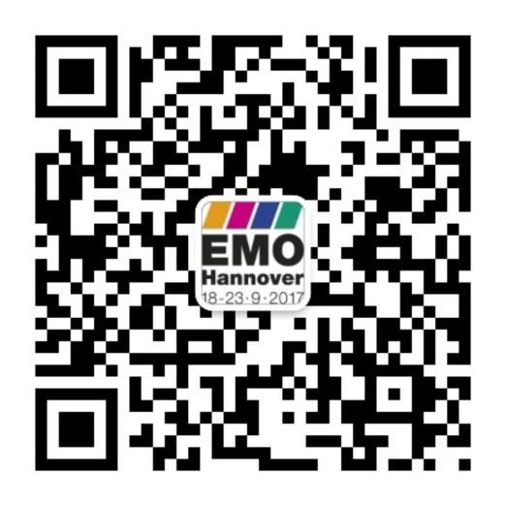
The green light is scheduled for mid-February 2017. To coincide with the six press conferences planned by the EMO’s organiser, the VDW (German Machine Tool Builders’ Association) in Beijing, Shenyang, Nanjing, Shanghai, Chengdu and Guangzhou, the EMO’s WeChat account 汉诺威国际机床工具展 is going online. “The VDW is opening it for EMO exhibitors as well, who can inform the Chinese customers about their presence at the fair free of charge,” says Dr. Wilfried Schäfer, Executive Director of the EMO’s organiser, the VDW.

The subscription account enables users to publish information three times a week. The focus here is on trends in the international machine tool industry, exhibitors and products at the EMO Hannover, interesting fringe events for the Chinese visitors, news of the preparations ongoing for the EMO, tips for how to get there and accommodation, the tour programme at the fair, Chinese delegations, and much, much more. Participation is free of charge for exhibitors if the information is supplied in the Chinese language.

“We’re entering virgin territory here,” says Dr. Wilfried Schäfer, Executive Director of the VDW in Frankfurt am Main. “However, the VDW has always endeavoured to support its members in their sales and marketing activities, and to be a pioneer for the sector with its initiatives as well.” In its WeChat project, the VDW is working together with the Tübingen-based storymaker agency.

With a machine tool production output of over 16 billion euros a year, China is the largest manufacturing nation, and with a consumption of more than 21 billion euros the world’s biggest market as well. Chinese exhibitors and trade visitors also rank among the EMO Hannover’s top customers. More than 100 Chinese exhibitors have already registered for the next event.

EMO Hannover 2017 – the world’s premier trade fair for the metalworking sector
From 18 to 23 September 2017, international manufacturers of production technology will be spotlighting “Connecting systems for intelligent production” at the EMO Hannover 2017. The world’s premier trade fair for the metalworking industry will be showcasing the entire bandwidth of today’s most sophisticated metalworking technology, which is the heart of every industrial production process. The fair will be presenting the latest machines, plus efficient technical solutions, product-supportive services, sustainability in the production process, and much, much more. The principal focus of the EMO Hannover is on metal-cutting and forming machine tools, production systems, high-precision tools, automated material flows, computer technology, industrial electronics and accessories. The trade visitors to the EMO come from all major sectors of industry, such as machinery and plant manufacturers, the automotive industry and its component suppliers, the aerospace sector, precision mechanics and optics, shipbuilding, medical technology, tool and die manufacture, steel and lightweight construction. The EMO Hannover is the world’s most important international meeting point for production technology specialists from all over the planet. In 2013, the fair attracted more than 2,130 exhibitors, and around 143,000 trade visitors from more than 100 different countries. EMO is a registered trademark of the European Association of the Machine Tool Industries CECIMO.

You will find texts and images relating to the EMO Hannover 2017 on the internet under www.emo-hannover.de in the Press section. You can also follow the EMO Hannover using our social media channels

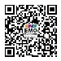 WeChat EMO汉诺威国际机床工具展
http://twitter.com/EMO_HANNOVER
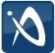 https://de.industryarena.com/emo-hannover
http://facebook.com/EMOHannover
http://www.youtube.com/metaltradefair

