March 2017

HELLER WerkTage 2017
Future prospects with added value

Press relations
Gebr. Heller Maschinenfabrik GmbH

Marketing
Marcus Kurringer
Gebrüder-Heller-Straße 15
72622 Nürtingen
Germany
Phone: +49 7022 77-5683
Fax: +49 7022 77-165683
marcus.kurringer@heller.biz
HELLER WerkTage 2017: Future prospects with added value
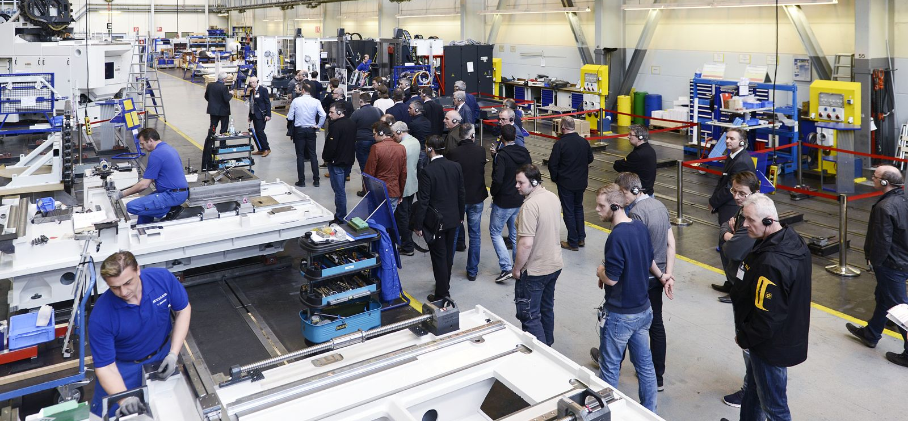
Under the motto “Made to Work”, HELLER had promised to present numerous highlights at the 10th HELLER WerkTage held from 15 to 17 March 2017. From the première of the new HF 5500 machining centre to new perspectives in terms of Industry 4.0 through to added value with HELLER Services: the machine manufacturer with headquarters in Nürtingen kept its promise. Visitors had the opportunity to gain impressive insights into how HELLER combines proven concepts with innovative ideas, creating measurable added value.
When it comes to developing new machining centres, HELLER continues to place the focus on productivity, performance, reliability and availability. With the new 5-axis machining centres from the HF series, HELLER has once again demonstrated this. At HELLER WerkTage held from 15 to 17 March 2017, the HF 5500 machining centre was presented for the first time. As customers have come to expect from HELLER, the machine features a horizontal spindle, providing quick tool changes, short idle times and free chip fall and is the perfect choice for dynamic 5-sided and simultaneous 5-axis machining. To enable this, its fifth axis is provided by the workpiece. HELLER uses proven kinematics with three linear axes in X, Y and Z and two direct driven, dynamic rotary axes in A and B. According to Christoph Schmidt, Product & Technology Management at HELLER, the counter bearing to support the direct driven AB axis provides a unique selling point over comparable concepts in the market. In combination with the YRT bearings, this helps to achieve the necessary rigidity even under high loads. Another first are the workpiece sizes. Whilst conventional 5-axis machining centres are mostly laid out for single-part clamping, HELLER's HF series provides the possibility to use multiple clamping or allows clamping of very large components. That is also why the interference contour of model HF 5500 has been enlarged by 27 percent compared to model HF 3500 to 800mm in height and 900mm in diameter. Despite this larger interference contour there are hardly any limitations in terms of the degrees of freedom. The machine enables swivel movements through 150° (30° to -120°).
During the event, visitors had the opportunity to experience for themselves the universality and capabilities of these machining centres, providing shortest chip-to-chip times. The demonstrations included machining of a 1.2312 steel component using a 100mm face-milling cutter. With a feed of ap = 3.5mm and an engagement width of ae = 75mm, it was possible to cut a chip volume of 470cm³. According to HELLER, the main target groups of the HF series are the general machine industry and automotive suppliers. That is also why the HF series will be available with four different spindle units and as a version for table loading or equipped with pallet changer and with HSK 63 and HSK 100 spindle taper.
Increasing productivity on workpiece level
In his presentation “HELLER 4Industry – added value for the future”, Bernd Zapf, Head of New Business & Technology at HELLER, explained that productivity and transparency form an integral part of Industry 4.0. HELLER distinguishes between three subject areas: HELLER4Operation, HELLER4Services and HELLER4Performance. HELLER4Operation focuses on ease of operation, individualisation of products and production and integration into the value chain, e.g. of ERP/CAD-CAM. HELLER4Services places the reduction of downtimes, preventative maintenance and evaluation of machine data in the foreground. HELLER4Performance is of special interest in the context of HELLER4Industry. It enables HELLER to provide the machine with added value and includes the workpiece-specific optimisation of the machine, expanding its known functional range. “Controlled chip tuning” allows to increase the productivity of the machining centres without any difficulty. Yet, the goal is not only to incorporate optimisations into the machine, but also to increase the effectiveness of the machine. In the future, these Industry 4.0 functions will be implemented through connecting the machine using a network and a communication box at the machine. In practical application this means that HELLER4Performance comprises the machine analysis for process and performance optimisation, time-synchronous extraction of real-time data into the internet as well as evaluation and graphical display, e.g. using an internet platform. This, for example, enables mapping of the tool paths including tolerances in which tool wear is expected. Subsequently, the workpiece program is run on the machine. The data generated is directly transferred to a cloud. This allows visualisation of the paths actually traversed by the tool in the workpiece design prior to machining to see whether the machine will be able to perform the operation.
Increased availability with transparent and condition-based solutions
With HELLER Services, HELLER provides maximum availability for maximum productivity. From financing solutions to the classic hotline, a dedicated CNC hotline through to specific maintenance or retrofitting options. Additionally, data services form an important part of the service package. For HELLER, this includes all services offered, involving the processing of data. In his presentation “HELLER Services – Lifetime Partnership”, Dr. Gerd Schöllhammer, Head of Sales Support Global Services at HELLER, focused on Remote Diagnostic Services (RDS), Condition Dependent Services (CDS) and the HELLER Services Interface. Whilst RDS allows to perform detailed diagnostics of the machine's operational state, CDS analyses the condition of the machine (data provided by axes, motors, etc.). The data captured is used to derive preventative measures for predictive maintenance. The HELLER Services Interface provides transparency for production and maintenance, results in an increase in productivity by identifying optimisation potentials and helps to reduce unscheduled downtimes through visualisation of the relevant parameters.
During HELLER WerkTage, the topic of availability was rounded off with presentations by Fastems, Schuler and Liebherr, focusing on pallet automation as a solution to achieve increased machine availability. Like previous events, this year's HELLER WerkTage again gave visitors an opportunity to gain insights into manufacturing and sub-assembly installation as well as large-part manufacturing and final assembly of machining centres.

HELLER AT A GLANCE
Founded in: 1894 in Nürtingen
2016 workforce: 2580
2016 order intake: EUR 527m
2016 turnover: EUR 538m
Chairman of the Board: Berndt Heller
Managing Directors of the HELLER Group: Klaus Winkler, CEO
Manfred Maier, COO
Dieter Drechsler, Projects & Applications
Patrick Rimlinger, Operations
Dr. Jürgen Walz, Development
Regional Managing Directors: Peter Weber, HELLER Europe
Andrew Parkin, HELLER Asia
Keith Vandenkieboom, HELLER North America
Alfredo Griesinger, HELLER South America
Fields of business: 4-axis and 5-axis machining centres
Mill/turning centres
Flexible manufacturing systems
Machines for crankshaft and camshaft machining
CBC systems
Services
Production locations: Germany (Nürtingen)
United Kingdom (Reddich)
USA (Troy/Michigan)
Brazil (Sorocaba)
China (Changzhou)
Sales/Service locations: EUROPE
Germany (Hattingen, Salem, Goslar, Saarbrücken, Nuremberg, Nürtingen)
Italy (Verona)
France (Paris)
Poland (Posen)
Spain (Barcelona)
Sweden (Värnamo)
Switzerland (Niederbüren)
Slovakia (Vráble)
Russia (Moscow)
NORTH/SOUTH AMERICA
Mexico (Querétaro)
Brazil (Belo Horizonte)
ASIA
China (Beijing, Chongqing, Shanghai)
India (Pune)
Thailand (Bangkok)
Singapore

