Press Release

Sliding/fixed headstock automatic lathe TRAUB TNL20
Productive and precise
The sliding/fixed headstock automatic lathe TRAUB TNL20 is a new development on the basis of the established TNL series that retains existing strengths and adds numerous improvements in productivity, precision, and automation. It is highly dynamic and – at its maximum equipment level – can use up to four tools simultaneously. The optional robot cell Xcenter - integrated in the machine - is available for automated production of sawing sections or preformed workpieces.
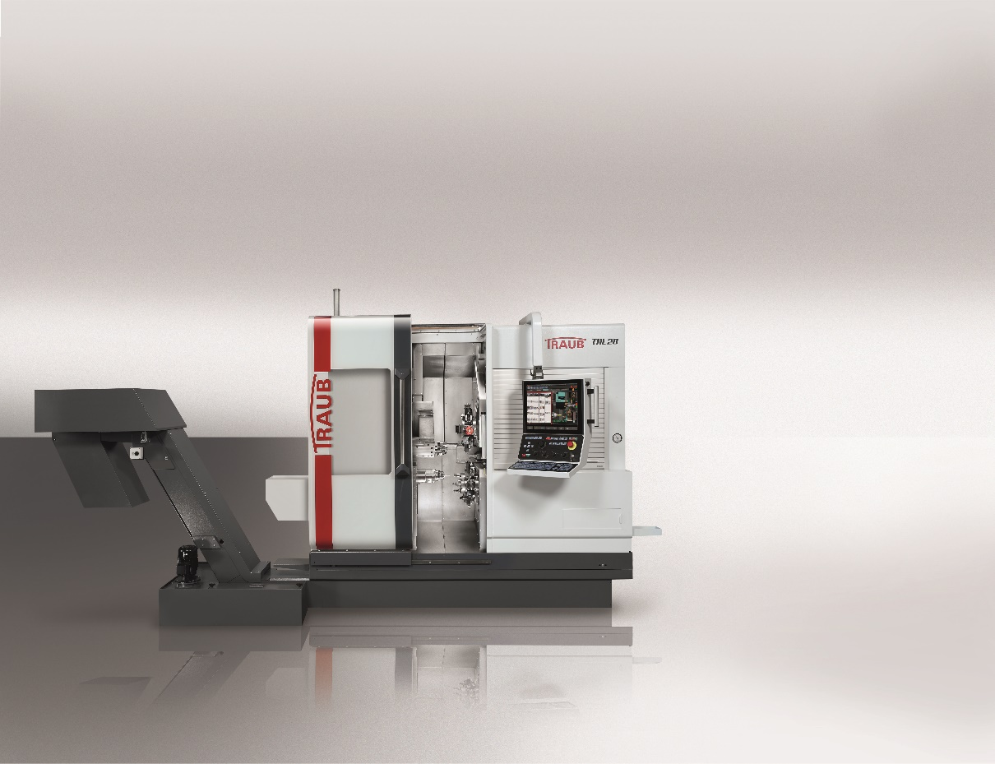

A first striking novelty is the new appearance of the sliding/fixed headstock automatic lathe TRAUB TNL20: The clearly structured exterior is based on the technical requirements – without unnecessary breaks and edges. Basic characteristics valued by users of previous TRAUB designs are retained, such as the large sliding guard at the front. It contains a generous large inspection window to the work area, as well as a roller shutter that allows comfortable access to the main spindle and its periphery.

The sleek outer design provides excellent conditions for the setup of the machine.

Another essential component of the new design is the control cabinet integrated completely into the machine cube. Any protruding elements are avoided, so that the right side of the machine is freely accessible for easy attachment of any bar loading magazine.

Layout and versions of the TNL20

The basis of the TNL20 is a rugged, extremely rigid and vibration-damping cast iron bed. All assemblies are built on it. The generous and vertically designed work area also ensures the necessary degrees of freedom for the machining of workpieces, as well as very high process reliability by the free chip flow.

The sliding/fixed headstock automatic lathe TRAUB TNL20 is launched in two versions. They can be variably equipped and excel by their high productivity: one equipment level is the TNL20-9, which has nine linear axes, two turrets (each with 8 stations, max. 12,000 rpm, 2.0 kW), a back working attachment (4 stations), and an autonomous counter spindle. So already with the TNL20-9, you can use three tools simultaneously, resulting in increased productivity.

The TNL20-11 is equipped with an additional front working attachment (6 stations, 3 of which are live, max. 12,500 rpm, 2.0 kW) on an autonomous X/Z slide. By the interpolation of the H indexing axis of the front working attachment with the X-axis of the autonomous compound slide, Y machining operations or tool offsets can also be easily performed with the front working attachment on the main spindle. At this equipment level, it is also possible to produce with up to four tools simultaneously to reduce machining times.

Powerful work spindles

Main and counter spindles (max. 10,000 rpm, 5.5 kW, 17.2 Nm) of the TNL20 are identical and designed as the liquid-cooled module motor spindles.

The work spindle has also a clearance in the draw tube of 29 mm, allowing the use of a standing reduction tube for bar stock diameters up to 20 mm. This ensures excellent guide quality that is ultimately noticed in the precision of the machined part. The guide bushings used in the TNL20 in sliding headstock operation are identical with those of its predecessor machine, the TNL18. The lathe can be converted in just a few minutes from fixed headstock to sliding headstock turning.

High productivity through clever kinematics

With its additional front working attachment, the TNL20-11 has a second upper tool carrier with six stations. Three tool mountings are live, one is equipped even with a double holder. The front working attachment has an autonomous compound slide in Z and X, as well as an NC swivel axis. By its interpolation with the X-axis, a Y-axis function can be implemented. This way the user can adjust his tool to the spindle center also simply by a position offset, which is of great importance, for example, for deep-hole drilling.

The back working attachment, which can be added both to the TNL20-9 and the TNL20-11, has been completely redesigned. While it was designed on the TNL18 as a separate unit, it is now arranged on the lower turret. It has four tool mountings arranged at sufficient distances, so that almost no disturbing edges develop with inactive tools during machining. It is easily accessible during setup and well visible when running in a CNC program.

The arrangement of the counter spindle and of the back working attachment provides an optimal power flow, thereby significantly improving the rigidity and precision of rear end machining.

Also, the axes of the lower turret can be coupled with the back working attachment and counter spindle, so that the back working attachment can be used for independent machining. This also contributes to an increase in productivity. While working simultaneously on the main spindle with the two turrets and the front working attachment, the counter spindle can be active at the same time with the back working attachment. So the TNL20-11 is capable of machining with four simultaneous tools and the TNL20-9 with three tools.

Generous tool carriers and sophisticated peripherals for flexible production

The TNL20-11 provides a total 26 tool stations. With the use of double and triple holders in the generously designed turrets, you can easily deploy up to 58 tools. The large tool pool allows the machining of complex workpieces and machining of entire part families without tool changes or major setup effort.

To optimally support all machining operations, a comprehensive cooling lubricant management is used. This includes 600 liters of coolant lubricant volume and up to four pump stations. In addition, an optional 120-bar pump ensures high-pressure supply, which is available also on the front and back working attachments. The resulting chips can be removed from the machine either with a drag link or slat band chip conveyor.

Parts handling and automation

Small parts can be easily and quickly flushed through a tube inserted in the indexing axis of the lower tool carrier onto a conveyor belt on the right of the machine and carried away.

For larger workpieces, an optional two-axis gantry unit is used that moves into the work area with a linear Z-axis and then swings in front of the counter spindle. After the gripper has taken over the part, the axis retracts. The workpieces are deposited individually.

Long workpieces can be discharged through the counter spindle up to a length of 700 mm.

As another possibility of automated machining of sawing sections or preformed blanks, the robot cell Xcenter has been developed and completely integrated into the machine. It is essentially comprised of an articulated arm robot and a vertical pallet storage device with 28 slots. This automation solution docked at the front allows the user to feed the sliding/fixed headstock automatic lathe even with parts that are larger than 20 mm in diameter. In addition, the robot cell is already prepared for integrating a 3D measuring device. Integrating other additional process steps, such as deburring, is possible as well.

Of course, you can also instruct the robot to unload and store workpieces produced from bar stock in the pallet storage device.

The robot cell and TNL20 are designed as a unit, and they are delivered to the customer as such.

For easy and ergonomic setup of the machine, the robot cell is completely movable. After releasing a lock, the user can slide it to an end position on the left, which then allows unrestricted access to the machine.

More control comfort

Industry 4.0 with: Xpanel i 4.0 ready

Xpanel allows access to the corporate IT network of customers via the control panel of the machine. With Xpanel your staff always has all relevant information for efficient production right at the machine. Xpanel is already included as standard in the Traub control and can be individually extended.

User friendliness:

The newly designed control panel with 19” multi- touchscreen in the center provides a familiar operating environment. This is ensured by the TX8i interface enhanced by gesture control. Intuitive gestures such as tapping, dragging, moving, swiping, zooming or rotating are possible similar to a smartphone or tablet. The override switches and the handwheel are still available on the machine control panel and arranged ergonomically as usual.

As usual with Traub, the control is upward-compatible. This means existing programs using the same axis kinematics can be transferred to the new control generation. The well-known WinFlexIPS programming system is available as usual on the control.

Speed:

In conjunction with a modified start-up strategy and the latest CFast memory technology, the control starts twice as fast as ever before. Thus, the machine is ready for production in minimal time.

A CNC CPU developed by Mitsubishi is used for the first time in the NC section. It is tailored specifically to the needs of a CNC machine and ensures an unprecedented block processing speed.

To extend this tremendous speed to the drives, the connection of the CNC control to the drive bus was equipped with a high-speed bus in the latest fiber optics technology.

Contact: INDEX-Werke GmbH & Co. KG
Hahn & Tessky
Michael Czudaj
Sales Manager Germany and Austria
by calling +49 711 3191-570
michael.czudaj@index-werke.de

Figure 1: The new TNL20 – productive sliding and fixed headstock turning of workpieces of medium
and high complexity from bar stock or with integrated robot cell

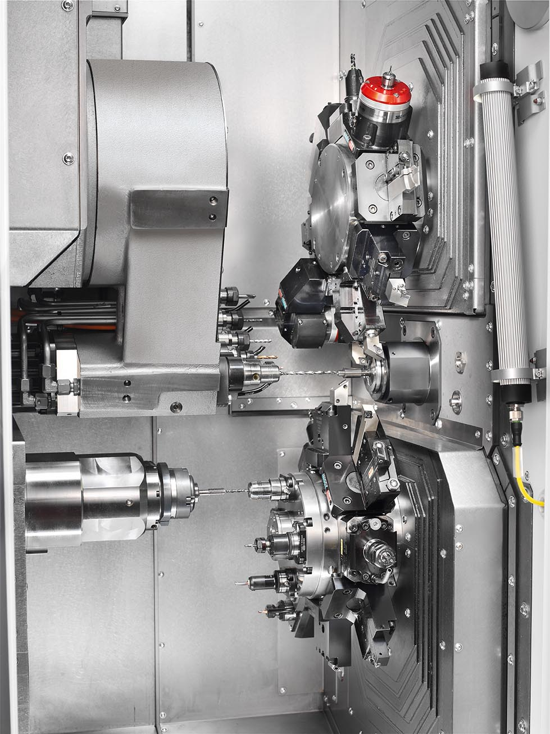
Figure 2: TNL20-9 – simultaneous and precise production with up to three tools
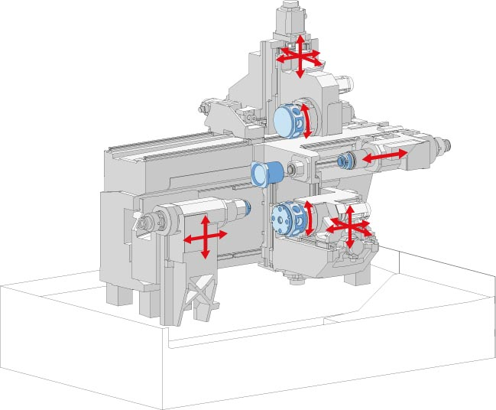

Figure 3: The work area concept Simultaneous and productive machining with two tool turrets and a front and back working attachment.

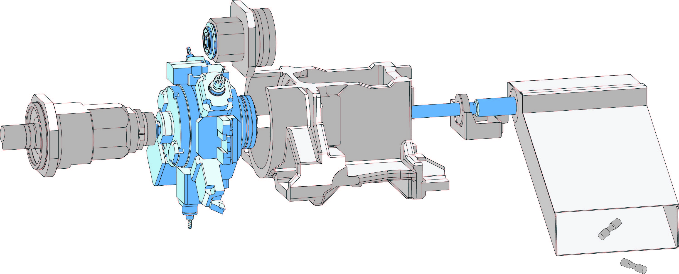

Figure 4: The workpiece discharge unit – fast, safe and gentle Flushing unit for workpieces
Small workpieces weighing up to approx. 150 g and up to 20 mm in diameter can be flushed out easily, quickly and gently from the counter spindle through the indexing shaft of the lower tool turret by means of an optional flushing unit.

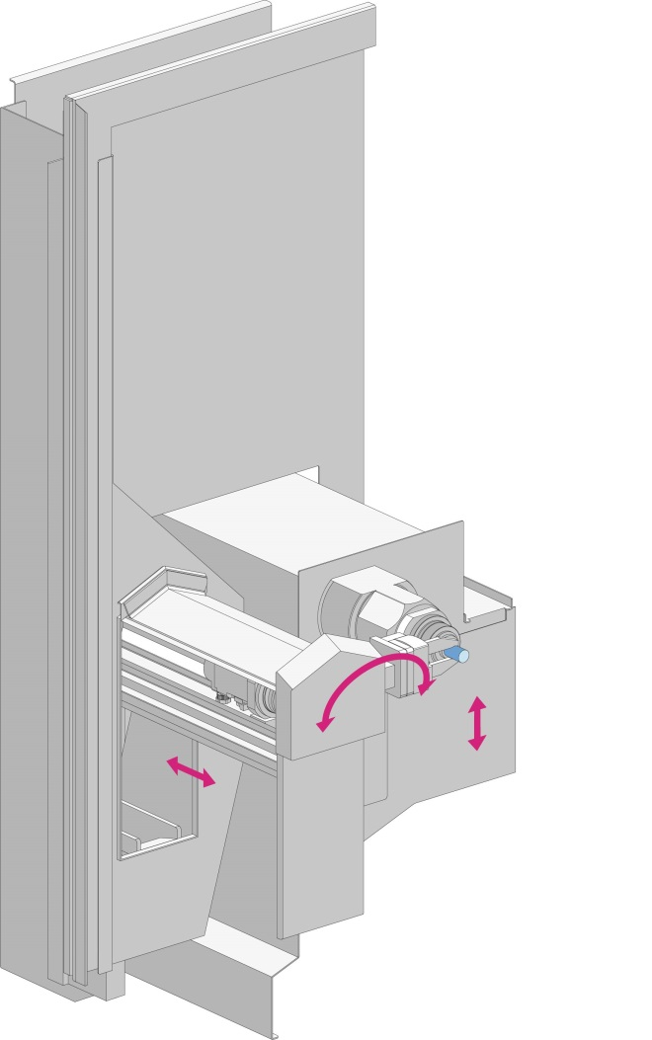

Figure 5: Workpiece removal unit
With the workpiece removal unit (servo linear axis in Z-direction and servo swivel axis), the
finished workpieces are removed with a workpiece gripper (two jaws, 20 mm stroke per jaw) and placed on a part removal conveyor.

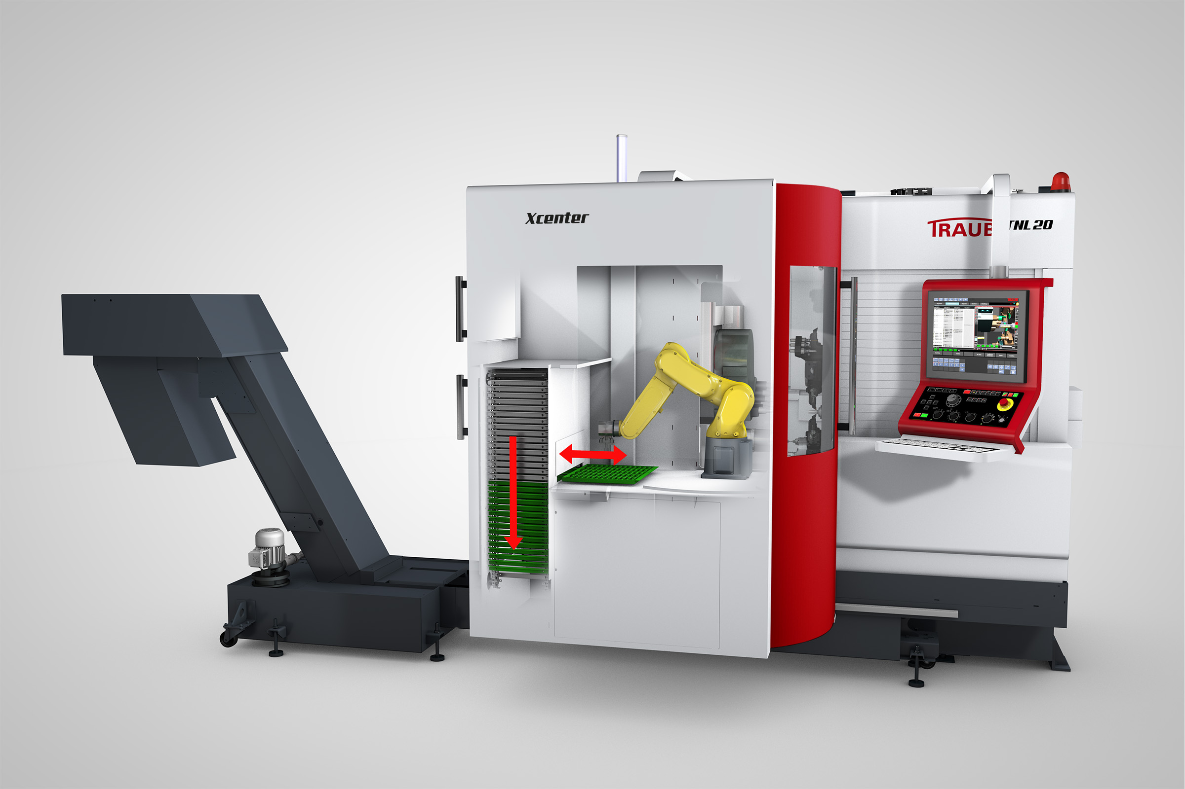

Figure 6: Integrate robot cell Xcenter
Intelligent automation – even more flexibility and efficiency With the optional robot cell, blanks and/or finished parts can be supplied and discharged quickly, safely and flexibly. The robot cell is integrated ergonomically into the machine. It can be moved easily to the left during the setup process, allowing unobstructed access to the work area of the machine.

